**SunTrac Design Team**

**Final Report**

**Kadeja Alhossaini**

**Nathan Firor**

**Edwin Smith**

**Ethan Vieane**

**2019-2020**



**Project Sponsor: SunTrac USA**

**Sponsor Mentor: Stu Siebens**

**Instructor: Sarah Oman**

# DISCLAIMER

This report was prepared by students as part of a university course requirement. While considerable effort has been put into the project, it is not the work of licensed engineers and has not undergone the extensive verification that is common in the profession. The information, data, conclusions, and content of this report should not be relied on or utilized without thorough, independent testing and verification. University faculty members may have been associated with this project as advisors, sponsors, or course instructors, but as such they are not responsible for the accuracy of results or conclusions.

# EXECUTIVE SUMMARY

The purpose of this project is to create a braze welding jig for a company called SunTrac USA which is located in Tempe, Arizona. SunTrac manufactures radiant solar panels that when coupled with variable speed or two speed Air Conditioning systems reduces the energy consumption of the AC system by up to 45 %. The most important component of these solar panels is a copper manifold that must be brazed on both ends and comes in three different sizes, 4 feet, 6 feet, and 8 feet. SunTrac has two jigs in their possession, one for the 6 feet manifold, and the other for the 8 feet, however they would like to have one jig that fits all three sizes. Our capstone team has been tasked to create a design for SunTrac that fits the company’s requirements.

To come up with an appropriate design, the team went through a vigorous selection process to make sure the appropriate design is selected. First the team came up with customer requirements (CRs) after speaking with the director of engineering at SunTrac. The most important customer needs are for the jig to be safe to operate, the cost of manufacturing the jig should be within the budget, and it should fit all three sizes of manifolds. Second, engineering requirements (ERs) were created to analyze the customer requirements quantitatively. Both the CRs and ERs were placed in a House of Quality (QFD) and analyzed to know which ER has the most technical importance. Moreover, the team came up with a black box model that developed into a functional decomposition model which details the different functions the design must be able to accomplish. The third step in this process is the team began brainstorming ideas using the Gallery Method. The ideas that worked best together were grouped in a design and put into a pugh chart and a decision matrix where they were weighted against each other. The best design was chosen through this process.

The selected design was similar to SunTrac’s existing 8 foot jig but had some major adjustments. It was similar because the jig that holds the pipes in place has a skeleton design and not a solid plate which allow easy access to the welding joints. One major adjustment was that the bars of the jig can elongate on both ends to account for three different sizes of manifolds. Another adjustment is a wire pull string that locks and frees the rotation of the jig. When the wire string is pulled, it will release the teeth of the gear from mechanical interference which in turn rotates the jig. Finally, the design also provides a winch that is connected to the back of the frame that allows variation in the working height of the jig.

To adopt the best design as the final design, some tests and analysis were conducted during and after the final manufacturing days. Five testing procedures were developed that ensure that all engineering requirements have been met. Most tests have already been completed with a few that have been delayed due to the COVID-19 pandemic. Moreover, a risk analysis will be implemented on the design for possible failure modes and possible design flaws. There are two parts to this analysis, the first will analyze the potential critical failures that will occur in the design and the second will deal with the trade-off analysis of the design.

After conducting the prior analysis, the results were considered in finalizing the full-scale prototype. The final design is similar to the best design however, it minimizes the amount of tubes used for the skeleton of the jig from five to three, and changed the foot pedal out for a pull string sub-system. It also uses a larger gear diameter for the locking mechanism. Moreover, the jig will be at an offset of a 11 degree angle to make sure it stands upright before it is bolted to the ground. Finally, specific calculations of the weight, thermal expansion, and gear force analysis were conducted to make sure the final design is safe and durable.

# ACKNOWLEDGEMENTS

Thank you SunTrac USA and Northern Arizona University for the support and experience designing, testing, and building a professional product to be used in industry. Special thanks to Stu Siebens and Sarah Oman for personally advising us through this project and directing us through the entire process.

# TABLE OF CONTENTS

DISCLAIMER ii

EXECUTIVE SUMMARY iii

ACKNOWLEDGEMENTS iv

TABLE OF CONTENTS v

1 BACKGROUND 2

1.1 Introduction 2

1.2 Project Description 2

2 REQUIREMENTS 3

2.1 Customer Requirements (CR’s) 3

2.2 Engineering Requirements (ER’s) 4

*2.2.1 ER #1: Melting Temperature* 5

2.2.1.1 ER #1: Melting Temperature Target = 1400 oC 5

2.2.1.2 ER #1: Melting Temperature Tolerance = -300 oC 5

*2.2.2 ER #2: Force to Rotate* 5

2.2.2.1 ER #2: Force to Rotate: Target = 13 Newtons 5

2.2.2.2 ER #2: Force to Rotate: Tolerance = ±3 Newtons 5

*2.2.3 ER #3: Cost under $1,600* 5

2.2.3.1 ER #3: Cost under $1,600: Target = $1,500 5

2.2.3.2 ER #3: Cost under $1,600: Tolerance = + $150 / - any 5

*2.2.4 ER #4: Number of Compatible Products* 6

2.2.4.1 ER #4: Number of Compatible Parts: Target = 3 Product Variations 6

2.2.4.2 ER #4: Number of Compatible Parts: Tolerance = +/- 0 6

*2.2.5 ER #5: Standard Parts* 6

2.2.5.1 ER #5: Standard Parts: Target = 90% of Parts 6

2.2.5.2 ER #5: Standard Parts: Tolerance = 10% of Parts 6

*2.2.6 ER #6: Footprint* 6

2.2.6.1 ER #6: Footprint: Target = 5ft x 5ft 6

2.2.6.2 ER #6: Footprint: Tolerance = + 1ft x 1ft 6

*2.2.7 ER #7: Degree of Rotation* 6

2.2.7.1 ER #7: Degree of Rotation: Target = 720 degrees 6

2.2.7.2 ER #7: Degree of Rotation: Tolerance = -360 degrees 7

*2.2.8 ER #8: Number of Locking Positions* 7

2.2.8.1 ER #8: Number of Locking Positions = 12 7

2.2.8.2 ER #8: Number of Locking Positions: Tolerance = - 4 / + any 7

*2.2.9 ER #9: Durability* 7

2.2.9.1 ER #9: Durability: Target = 5 years 7

2.2.9.2 ER #9: Durability: Tolerance = - 1 year 7

*2.2.10 ER #10: Tolerance/ Error* 7

2.2.10.1 ER #10: Tolerance/ Error: Target = 0 7

2.2.10.2 ER #10: Tolerance/ Error: Tolerance = +/- 1/16” 7

2.3 Functional Decomposition 8

*2.3.1 Black Box Model* 8

*2.3.2 Functional Model/Work-Process Diagram/Hierarchical Task Analysis* 8

2.4 House of Quality (HoQ) 9

2.5 Standards, Codes, and Regulations 10

3 Testing Procedures (TP’s) 12

3.1 Testing Procedure 1: Critical Length 12

*3.1.1 Testing Procedure 1: Objective* 12

*3.1.2 Testing Procedure 1: Resources Required* 12

*3.1.3 Testing Procedure 1: Schedule* 12

*3.1.4 ER’s Tested* 12

3.2 Testing Procedure 2: Heat Exposure 13

*3.2.1 Testing Procedure 1: Objective* 13

*3.2.2 Testing Procedure 1: Resources Required* 13

*3.2.3 Testing Procedure 1: Schedule* 13

*3.2.4 ER’s Tested* 13

3.3 Testing Procedure 3: Final Cost 13

*3.3.1 Testing Procedure 1: Objective* 13

*3.3.2 Testing Procedure 1: Resources Required* 14

*3.3.3 Testing Procedure 1: Schedule* 14

*3.3.4 ER’s Tested* 14

3.4 Testing Procedure 4: Rotation Assessment 14

*3.4.1 Testing Procedure 1: Objective* 14

*3.4.2 Testing Procedure 1: Resources Required* 14

*3.4.3 Testing Procedure 1: Schedule* 15

*3.4.4 ER’s Tested* 15

3.5 Testing Procedure 5: Final Dimensions 15

*3.5.1 Testing Procedure 1: Objective* 15

*3.5.2 Testing Procedure 1: Resources Required* 15

*3.5.3 Testing Procedure 1: Schedule* 15

*3.5.4 ER’s Tested* 15

4 DESIGN SPACE RESEARCH 16

4.1 Literature Review 16

4.2 Benchmarking 16

*4.2.1 System Level Benchmarking* 17

4.2.1.1 Existing Design #1: Horizontal Table 17

4.2.1.2 Existing Design #2: 6’ Braze Welding Jig 17

4.2.1.3 Existing Design #3: 8’ Braze Welding Jig 18

*4.2.2 Subsystem Level Benchmarking* 18

4.2.2.1 Subsystem #1: Frame Roto-Locking 18

*4.2.2.1.1 Existing Design #1: Pin Lock* 19

*4.2.2.1.2 Existing Design #2: Swing Arm Lock* 19

4.2.2.2 Subsystem #2: Frame Configuration 19

*4.2.2.2.1 Existing Design #1: Skeleton Frame* 19

*4.2.2.2.2 Existing Design #2: Solid Plate Frame* 19

*4.2.2.2.3 Existing Design #3: Wooden Table* 19

4.2.2.3 Subsystem #3: Base Structure 19

*4.2.2.3.1 Existing Design #1: Bent T Base* 20

*4.2.2.3.2 Existing Design #2: Rectangular Beam Base* 20

*4.2.2.3.3 Existing Design #3: Rectangular Solid Base* 20

5 CONCEPT GENERATION 21

5.1 Full System Concepts 21

*5.1.1 Full System Design #1: DA 1 Circular Slides and Swivel Latches* 21

*5.1.2 Full System Design #2: DA 4 Rectangular Slides and Power Screws* 22

*5.1.3 Full System Design #3: DA 6 Rectangular Slides and Swivel Latches* 22

5.2 Subsystem Concepts 24

*5.2.1 Subsystem #1: Maneuvering and Locking the Jig* 24

5.2.1.1 Design #1: Ball Bearing Pivot With Foot Pedal Lock 24

5.2.1.2 Design #2: Ball Bearing and Pull Handle Lock 24

5.2.1.3 Design #3: Crank Handle 25

*5.2.2 Subsystem #2: Locking Vertical Pipes* 25

5.2.2.1 Design #1: U-standoff 26

5.2.2.2 Design #2: V-standoff 26

5.2.2.3 Design #3: Latch 27

*5.2.3 Subsystem #3: Locking Horizontal Pipes* 27

5.2.3.1 Design #1: Swivel latch 27

5.2.3.2 Design #2: Power Screw 28

5.2.3.3 Design #3: Simple Clamp 28

*5.2.4 Subsystem #4: Adjusting Size* 28

5.2.4.1 Design #1: Circular Slides 29

5.2.4.2 Design #2: Rectangular Slides 29

5.2.4.3 Design #3: Modular Design 29

*5.2.5 Subsystem #5: Standing Upright* 30

5.2.5.1 Design #1: Leaning Base Bolted to the Ground 30

5.2.5.2 Design #2: Bolted into the Wall 31

5.2.5.3 Design #3: “n” Shape Bolted to the Ground 31

*5.2.6 Subsystem #6: Locking Brass Brackets* 33

5.2.6.1 Design #1: Indented Surface With Slider 33

5.2.6.2 Design #2: Built in Clamp 33

5.2.6.3 Design #3: Slides into Place 34

6 DESIGN SELECTED – First Semester 35

6.1 Design Description – First Semester 35

*6.1.1 Design Preliminaries and Changes Made* 35

*6.1.2 Engineering Calculations* 36

6.1.2.1 Reduced Weight Analysis 36

6.1.2.2 Thermal Expansion Maximum Axial Stress 36

6.1.2.3 Gear Force Analysis 37

*6.1.3 First Prototype* 38

6.2 Implementation Plan – First Semester 39

*6.2.1 Needed Resources* 39

*6.2.2 Implementation Schedule* 39

*6.2.3 CAD Model Views* 41

7 IMPLEMENTATION – Second Semester 44

7.1 Manufacturing 44

7.2 Design Changes 44

8 RISK ANALYSIS AND MITIGATION 45

8.1 Potential Failures Identified Fall Semester 45

*8.1.1 Potential Critical Failure 1: Gear Tooth Bending Fatigue (RPN 54)* 46

*8.1.2 Potential Critical Failure 2: Large Steel Tube Ductile Fracture (RPN 54)* 46

*8.1.3 Potential Critical Failure 3: Small Steel Tube Ductile Fracture (RPN 54)* 46

*8.1.4 Potential Critical Failure 4: Large Tube Abrasive Wear (RPN 48)* 46

*8.1.5 Potential Critical Failure 5: Small Tube Abrasive Wear (RPN 48)* 46

*8.1.6 Potential Critical Failure 6: Large Steel Tube High Cycle Fatigue (RPN 48)* 46

*8.1.7 Potential Critical Failure 7: Small Steel Tube High Cycle Fatigue (RPN 48)* 47

*8.1.8 Potential Critical Failure 8: Ball Bearing Spalling (RPN 48)* 47

*8.1.9 Potential Critical Failure 9: Rod Impact Wear (RPN 48)* 47

*8.1.10 Potential Critical Failure 10: Pull Handle Tensile Yield (RPN 48)* 48

8.2 Risk and Trade Off Analysis 48

8.2 Risk Mitigation 49

9 TESTING 50

10 FUTURE WORK 50

11 CONCLUSIONS 51

11.1 Contributors to Project Success 51

11.2 Opportunities/areas for improvement 53

12 REFERENCES 55

13 APPENDICES 56

13.1 Appendix A: House of Quality 56

13.2 Appendix B: Bill of Materials 57

13.2.1 Appendix B: Bill of Materials Summary 57

13.3 Appendix C: Full Risk Trade Off Analysis 58

13.4 Appendix D: Full Components FMEA 59

# 

# 1 BACKGROUND

## 1.1 Introduction

This capstone project consists of redesigning the braze welding jig that is currently in use at SunTrac USA. Braze welding is that art of binding two pieces of softer metals together like copper or brass using a heat source and filler wire. The objective of this project is to design a new braze welding jig that is compatible with SunTrac’s 8’, 6’, and 4’ product variants. These product variants are a series of copper tubes arranged in an array to transport refrigerant. This project is important to SunTrac because they are projected to grow exponentially in the next three years and need to be ready for the increase in demand for their products following the COVID-19 pandemic. This product solves issues relating to lean manufacturing and ensures that SunTrac is using floor space efficiently and reducing the time in which machinery/tools are idle.

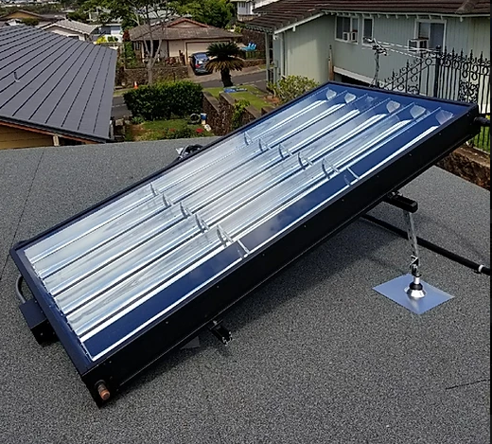

**Figure 1:** Completed 8’ Product Variant

## 1.2 Project Description

Following is the original project description provided by the sponsor:

The director of engineering for SunTrac USA (please see www.suntracusa.com) would like a capstone team to create a system to help with manufacturing. We manufacture a radiant solar panel that when coupled with variable speed or two speed Air Conditioning systems reduces the energy consumption of the AC system by up to 45 %.

One of the key components of our system is a series of (6) 5/8” diameter copper tubes that must be brazed at both ends into a 1-1/8” copper tube. We call this a “copper manifold” and we make it in three different lengths (4 ft, 6 ft, and 8 ft).

What I would like your team to do is design and build a brazing jig that would give us the flexibility to do any of the three lengths on the same jig. The function of the jig is to hold all the copper pipes in place while they are brazed together. SunTrac would provide all the materials at no cost to the students. What we would like is for your team to design the jig and draw up the parts needed to assemble the fixture. We would have the parts made to their drawings and they could assemble the finished product. We would like to extend an invitation to the team that will be working on this project to visit our facility in Tempe AZ. Seeing how we do things now would be a good start for the team to get the wheels turning [1].

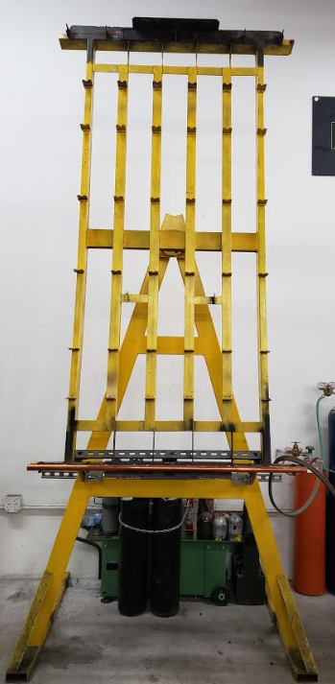

**Figure 2:** Existing 8’ Braze Welding Jig

# 2 REQUIREMENTS

The requirements that were set by SunTrac USA are listed in the customer needs and their resulting engineering requirements. These data sets are then further analyzed in a House of Quality to determine correlations in the data as well as ranking the engineering requirements. The highest priority customer requirements are safety, cost, and the ability for the welding jig to be compatible with all three product variants. This section expands further to the data listed above and provides data to support the decisions made in the design selection.

## 2.1 Customer Requirements (CR’s)

The customer needs are listed below with their associated weights.

1. Safe to Operate 5
2. Cost within budget 5
3. Can fit a 4’, 6’, and 8’ copper manifold 5
4. Machinable parts 4
5. Fit within a 5’x5’ square 3
6. Allow easy access to all copper joints 4
7. Jig can rotate and lock at various angles 3
8. Durable and Robust design 4
9. Reliable design 4

The weighting system used for the customer needs included a one to five ranking with five being the most important need for the client. The customer needs and weights were given to us from Suntrac directly. The first customer need is for the system to be safe to operate. This was given a high weight because safety is a priority that is stressed at SunTrac. The second customer need is for the system to be within budget. This was given a weight of five because Suntrac desires this to be a cheap and easily repeatable design. The third customer need is for the braze welding jig to be compatible with SunTracs 4’, 6’, and 8’ product variants. This was given a weight of five because Suntrac wants this system to employ lean manufacturing principles and have multiple functions within their manufacturing facility.

The next set of customer needs were given a ranking of four given their high importance but lower priority than the other needs. These needs include that the system is made with standard parts to keep costs down. Suntrac also desires a braze welding configuration that allows easy access to all copper joints. This customer need specifies that the jig should allow access to the copper joints even from behind the jig. The last two customer needs that are given a weight of four are that the braze welding jig has a durable and robust design while also being reliable. This customer needs details how the jig should be strong enough to complete its designed task and continue to function optimally for many years into the future.

The last set of customer needs are given a weighting of three because they are still important but have the smallest priority. The first customer need in this category is that it fits within a 5’x5’ square footprint. SunTrac specified that they prefer this customer need to be met but will accept designs with larger footprints if all other needs are met. The last customer need is for the jig to be able to lock in many different configurations. This need was given a weight of three because the braze welding jig is still as functional as the original design as long as two locking positions are permitted.

## 2.2 Engineering Requirements (ER’s)

For each customer requirement stated in the previous section, an engineering requirement is formed. The purpose of an ER is to verify and set a target value or tolerance for each CR used. Since the CR’s did not change, the engineering requirements stayed the same to satisfy them. The parameters and tolerances however, varied slightly since more analytical analysis has been conducted. Any changes that have been made will be discussed along with the reason that led to its alteration below. In addition to this, a table has been provided to concisely detail all engineering requirements. All factors of safety require a 2.0 or greater as detailed by SunTrac USA.

1. Melting Temperature (degrees Celsius) 1400 ± 300
2. Force to Rotate (Newtons) 13 ± 3
3. Cost (dollars) 1600 + 150
4. Versatile (number of compatible product variations) 3 ± 0
5. Standardized Parts (Percentage) 90% ± 10%
6. Footprint (feet^2) 25 + 1
7. Degree of Rotation (Radians) 2pi ± 0
8. Adaptable (Number of locking positions) 12 ± 4
9. Durable (Years before repair) 5 - 1
10. Error (Difference in desired length) (in) 0 ± 1/16”

### *2.2.1 ER #1: Melting Temperature*

#### 2.2.1.1 ER #1: Melting Temperature Target = 1400 oC

The process of braze welding involves very high temperatures to melt and adhere the copper. Conductive heat transfer to the Jig is certainly unavoidable so it needs to be made out of material that can withstand this temperature. Being a robust and reliable design involves satisfying this requirement.

#### 2.2.1.2 ER #1: Melting Temperature Tolerance = -300 oC

Locally where the braze welding occurs, the temperature is approximately 1400 degrees Celsius, but heat transfer out of the system is significant since copper is a very thermally conductive material, so this temperature does not reach the Jig itself. The melting temperature of the material for the Jig face can certainly be above this limit, but should not be more than 300 degrees beneath this target.

### *2.2.2 ER #2: Force to Rotate*

#### 2.2.2.1 ER #2: Force to Rotate: Target = 13 Newtons

The Jig should not provide much difficulty under operation, so when rotating the face, it should be done with relative ease. However, if it should freely rotate this would be a safety hazard since it has a large swing arm and is heavy. So, the team designated that there should be some, but not significant, resistance to rotation. Then since the apparatus is symmetrical about the axes, it is balanced so gravity shouldn't pose much of an effect to accelerate the swing. This involves the use of a bearing or bushing to support the axle that the Jig face is supported on.

#### 2.2.2.2 ER #2: Force to Rotate: Tolerance = ±3 Newtons

When pushed at either end of the Jig, the moment arm is significant about the axis due to the jig size. A proper bearing or bushing can fulfill this tolerance to allow the Jig to be easy to operate but not unsafe.

### *2.2.3 ER #3: Cost under $1,600*

#### 2.2.3.1 ER #3: Cost under $1,600: Target = $1,500

The client was able to increase the overall budget to $1,600 from the $1,000 that was set last semester. This number is based on the fact that $1,500 was spent on their 6-foot jig, which they approved as a reasonable cost. The team believes the cost should not exceed $1,300 based on the current Bill of Materials. This budget leaves room for unexpected contingency costs.

#### 2.2.3.2 ER #3: Cost under $1,600: Tolerance = + $150 / - any

The maximum cost for the project materials is now set at $1,600 and the team decided that this cost is reasonable and will likely be met with money left over. The team is set to design towards only using $1,300 to allow a contingency of $300.00.

### 

### *2.2.4 ER #4: Number of Compatible Products*

#### 2.2.4.1 ER #4: Number of Compatible Parts: Target = 3 Product Variations

Suntrac USA employs three lengths of manifolds to be constructed (4’, 6’, and 8’ lengths). Thus, the jig is designed to configure for each of the manifold configurations and maintain tolerances.

#### 2.2.4.2 ER #4: Number of Compatible Parts: Tolerance = +/- 0

There is no room for less than three configurations because this is a main requirement from SunTrac. Our project is contingent on all three project variants being compatible with our design.

### *2.2.5 ER #5: Standard Parts*

#### 2.2.5.1 ER #5: Standard Parts: Target = 90% of Parts

With regard to design reproducibility, components that make up the Jig are to be composed of standardized parts, that way should SunTrac want more Jigs, parts can be purchased without fulfilling custom orders, this helps keep costs low. However, the Jig fulfills a rather specific goal with some special tolerances so there are some parts that need to be custom made.

#### 2.2.5.2 ER #5: Standard Parts: Tolerance = 10% of Parts

There are components like the stand and the telescoping tubes that comprise the Jig face which are made from standardized parts. These are square extrusions of steel tubes that are commonly and cheaply produced. They are not manufactured in these exact lengths but Suntrac USA is capable of making these cuts to length. Other components like the power screws and end plate are designed to hold specific pieces of the manifolds to within a tolerance length, so these parts will need to be specially machined to fulfill that requirement.

### *2.2.6 ER #6: Footprint*

#### 2.2.6.1 ER #6: Footprint: Target = 5ft x 5ft

Much like with their currently employed jig design, Suntrac is willing to utilize a 5 by 5 ft square of floor space for the Jig to occupy. Their facilities however have high ceilings so height requirement is not needed.

#### 2.2.6.2 ER #6: Footprint: Tolerance = + 1ft x 1ft

This requirement is a relatively loose one that the team needs to follow, but necessary considerations should be made to satisfy it. A maximum footprint of 6 by 6 ft space should be easily attainable and has been approved by SunTrac.

### *2.2.7 ER #7: Degree of Rotation*

#### 2.2.7.1 ER #7: Degree of Rotation: Target = 720 degrees

It is intended to have the jig rotate indefinitely. This sort of requirement is most achievable by using a cylindrical axis as part of a hub or a roller bearing. This will allow the jig to continuously rotate unless stopped by a locking mechanism.

#### 2.2.7.2 ER #7: Degree of Rotation: Tolerance = -360 degrees

Considering how the brazing process is done, only one full rotation of the Jig face needs to be done. That being said, one rotation is all that's needed but it would restrict the user from continuously rotating the jig in the same direction.

### *2.2.8 ER #8: Number of Locking Positions*

#### 2.2.8.1 ER #8: Number of Locking Positions = 12

It is crucial that the Jig is capable of locking in a variety of positions to allow for easy access to all the copper points. Yet the Jig cannot freely rotate so a worker can braze weld safely. The current jig allows for six locking positions (three on each side) but this amount has been found to be restricting and they would like more locking positions.

#### 2.2.8.2 ER #8: Number of Locking Positions: Tolerance = - 4 / + any

Suntrac has no problem with as many locking positions as possible. Their current braze worker stated that at least 12 would be suitable but would be fine with eight. Our design clearly achieves this requirement.

### *2.2.9 ER #9: Durability*

#### 2.2.9.1 ER #9: Durability: Target = 5 years

Longevity is particularly important for the Jig since it is such a crucial component in Suntrac’s manufacturing process. They requested that the Jig last for several years and incur minimal maintenance operations. The team interpreted this as at least five years without maintenance.

#### 2.2.9.2 ER #9: Durability: Tolerance = - 1 year

Of course, if the design is very reliable it would not have to be operated on for even more years. Establishing a limit is necessary, and the team decided at least four years of withstanding continuous operation is desirable.

### *2.2.10 ER #10: Tolerance/ Error*

#### 2.2.10.1 ER #10: Tolerance/ Error: Target = 0

Zero error means that the Jig is capable of manufacturing the copper manifold to the specified dimensions accurately. Perfect tolerances are desirable but of course unattainable. Gd&t principles in our design must be applied in such a way to have the error approach zero. This ER is important because if a manifold is not manufactured within the tolerances it is unusable.

#### 2.2.10.2 ER #10: Tolerance/ Error: Tolerance = +/- 1/16”

The manifold itself gets inserted into a thermally insulated box as part of Suntrac’s product. The brass brackets on each end of the copper manifold are intended to be close to the opposing walls within this box. Then the mirrors that concentrate solar light onto the copper pipes are also placed close together and under no circumstance can interfere with each other. The tolerance utilized here translates to the Jig and how it's manufactured so that it can produce manifolds with this tolerance. An error of 1/16” would allow the jig to continue to operate under normal circumstances.

## 2.3 Functional Decomposition

The process of creating the functional decomposition began during the in-person visit to SunTrac’s manufacturing facility. During the visit, the director of engineering at SunTrac gave the team a tour of the facility and detailed the braze welding process within the scope of this capstone project. One of the results of this meeting was the knowledge to create the first draft of the hypothesized functional model for the new braze welding jig. SunTrac explained that the final result of this project must be able to support eight copper pipes and four brass standoffs in the correct orientations while maintaining tolerances during the braze welding process. The main edit from the hypothesized functional model to the final functional model was the subsystem of locking the rotation of the braze welding jig. Due to the simple design there were a few locations in the functional model where edits were required. This model is still accurate now, during the end of the project.

Notable subsystems that are listed in the final functional include adjust/ lock orientation, import components, position components, secure components, and join components. The scope of this project as detailed from SunTrac is to create a jig that has the capability of changing orientation while also securing all components in place. The other subsystems that detail the process of building a copper manifold fall outside the scope of this project. Due to the large quantity of parts and small degree of tolerance, many different components must be employed to satisfy the one subsystem of Secure Components as seen in the final CAD drawing.

### *2.3.1 Black Box Model*

After minor revisions the final material flows for this process are the components and human for inputs and the completed manifold and human for outputs. The final energy flows for this system include human and thermal input energies while just thermal energy remaining as an output. The signals used in this design include olfactory, visual, and auditory as both input and output flows. These signals are shown in the final functional model as sensory checks to ensure the braze welding process is being done correctly. These inputs and outputs are largely unchanged from the initial prototype to the final interactive prototype.

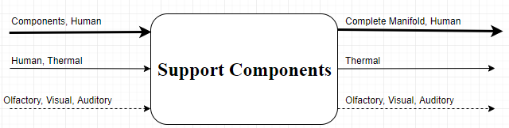

**Figure 3:** Black Box Model

Figure three clearly shows the black box model for the team’s final functional model. Notable features of this figure include that components enter the material flow and the completed manifold exits the material flow. This figure is important because it shows the main objective of this project. The black box model also states that “Support Components” is the main function that needs to be accounted for when designing this project. This model helps the team clarify our project by neglecting all subsystems and stating the main purpose of the team's device. This figure also helps the team refocus our efforts on satisfying the main goal instead of focusing on every minor detail.

### *2.3.2 Functional Model/Work-Process Diagram/Hierarchical Task Analysis*

The team took the black box model and expanded it to create the final functional model. Due to the braze welding jig having a clear and defined purpose, the inputs and outputs of the model have remained nearly unchanged from its initial conception to its use in the final report.

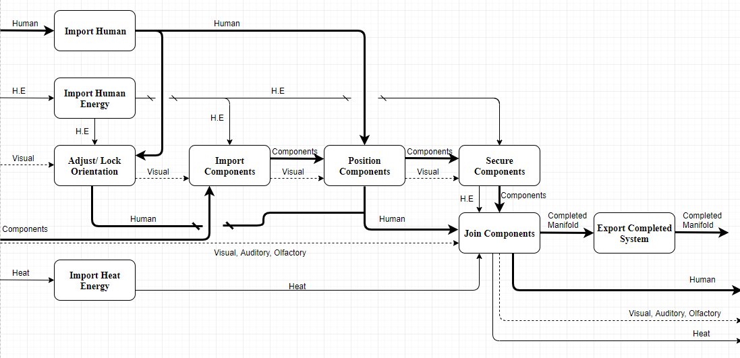

**Figure 4:** Functional Model Diagram

Figure four displays the team's final functional model for SunTrac’s braze welding jig. Edits that were made between the hypothetical and final function models include adding a subsystem of “Lock Jig Orientation” and propagating the “human” material flow throughout the entire model. This model helps visualize the project by detailing every subsystem that our team must articulate into the design. Whereas the black box model states the main function of the design, the final functional model details how that main function is achieved. This figure is important because it ensures every subfunction is accounted for in the design and the scope of the project is fully defined. The design selected closely relates to the final functional model with slight variations to the methods in which subsystems are accomplished that are better expressed in the final CAD package.

## 2.4 House of Quality (HoQ)

The House of Quality details the correlation between the customer needs that were provided from SunTrac USA and the team derived engineering requirements. The completed House of Quality as well as the approvals and associated testing procedures are listed in Appendix A. The correlations between ER's and CR’s are found through each weight and multiplying them by the correlation values which are the values assigned in the large matrix. Those values are summed up and compared to each other to determine the absolute and relative technical importance of each. The highest values denote the most important criterion to satisfy.

The most important engineering requirement for this project is decreasing cost, which has an absolute technical importance of 17% . The least important is minimizing the force required to rotate the jig face at 7% priority. Even though the two differ the most on their importance, both are impacted by customer requirements like durability and robustness as well as costing within the budget. Further details on the engineering requirements and their technical importance rankings are available in Appendix A.

## 2.5 Standards, Codes, and Regulations

In this project, the standards, codes, and regulations, were important factors to consider while manufacturing the system. SunTrac is a company that is recognized globally, therefore it is necessary to ensure the brazing jig complies to these standards. Since the system was not fully built due to the COVID-19 outbreak, some standards were not tested but they still factor in the manufacturing left to complete the final product and its testing. The table that is presented below lists the regulations and standards that impact the manufacturing and testing process. Details of how each standard applied to the project will also be discussed. The table will clearly show which standards are already achieved and the standards that would have been achieved if the manufacturing and testing process was completed. Most of the standards and regulations were already listed in the Final Proposal that was created last semester, but a few adjustments were made for the report this semester.

**Table 1:** Standards and Codes Applied to this Project

|  |  |  |
| --- | --- | --- |
| **Standard Number or Code** | **Title of Standard** | **How it applied to Project** |
| OSHA 1910.24 [2] | Occupational Safety and Health Standards | This standard was used to make sure the material of the bolts that were used in manufacturing are made up of a material that protects against corrosion, and the bolts are capable of supporting their maximum intended load. |
| ASTM  E3052-16 [3] | Standard Practice for Examination of Carbon Steel Welds Using Eddy Current Array | This standard would have been used to detect surface-breaking cracks on the joints of the jig where it is welded together. |
| ANSI/AGMA  1010-F14 [4] | Appearance of Gear Teeth- Terminology of Wear and Failure | This standard was used to predict the most common types of gear teeth failure which assisted us with choosing a gear with an appropriate number of teeth to be used in the locking mechanism. |
| ANSI/AGMA  2004-C08 [5] | Gear Materials, Heat Treatment and Processing Manual | This standard was used to choose an appropriate gear material with respect to the surrounding environment, weight limitations, and component geometry. |
| ASME  Y14.5 [6] | Dimensioning and Tolerancing | This standard was used when dimensioning and tolerancing in drawings, models and document files according to GD&T. |
| ASTM  A606/A606M [7] | Standard Specification for Steel, Sheet and Strip, High-Strength, Low-Alloy, Hot-Rolled and Cold-Rolled, with Improved Atmospheric Corrosion Resistance | This standard was used to choose Hot-Rolled Carbon Steel material for the frame of the welding jig. |
| ASTM  A489 [8] | Standard Specification for Carbon Steel Eye Bolts | This standard was used in choosing an appropriate galvanized steel eye bolt that mounts the pulley onto the jig frame. |

# 

# 3 Testing Procedures (TP’s)

This section discusses the testing procedures that will be developed to ensure the Engineering Requirements have been satisfied. It is important to have these tests as they will determine if the device is durable and also eliminate the chance of the device breaking any standards, codes, or regulations. For the purpose of this project, the team has created five different testing procedures. First, the objectives of these tests will be discussed and also the details about how these tests will be performed. Next, details about the testing equipment used along with the means of acquiring this equipment will be analyzed. Finally, the schedule needed to perform these tests will be listed as well as the engineering requirements that they satisfy. All testing will be performed at SunTracs’ manufacturing facility, all resources will be sourced from their warehouse.

## 3.1 Testing Procedure 1: Critical Length

### *3.1.1 Testing Procedure 1: Objective*

There are three objectives for this test. The first objective is to test whether a large centrifugal force will change the critical length of the jig. The second objective is to see if each size copper manifold will fit in the braze welding jig. The third objective is the test if the jig will rotate a full 360 degrees. This test includes taking a length measurement of the jig at the four-foot configuration before changing the jig to the eight-foot configuration and locking it vertically. The next step is to release the locking mechanism before spinning the jig as fast as the user can manage. Once the jig comes to a stop, the final step is to set the jig back in the four-foot configuration and re-measuring the length. This test is conducted because it satisfies all the above objectives as one test. If there are no differences in lengths, the Error requirement is satisfied. If all three configurations of copper manifolds fit in the jig the Versatility requirement is satisfied. Finally, if the jig rotates a full 360 degrees the Degree of Rotation requirement is met.

### *3.1.2 Testing Procedure 1: Resources Required*

The required resources for this test include the completed full scale braze welding jig as well as the SunTrac manufacturing facility, the SunTrac team, Stu Siebens, and a tape measure. The completed jig needs to be bolted to the floor and therefore needs the manufacturing facility. The team and Stu Siebens will be there to monitor the experiment and a tape measure will be used to measure the change in the critical length of the braze welding jig.

### *3.1.3 Testing Procedure 1: Schedule*

This test will take approximately 15 minutes to conduct and record. If any additional trials are requested it will take an additional 15 minutes per trial. This test will likely be run during the beginning of June when the full scale braze welding jig is assembled and installed. This test is dependent on manufacturing space, having the prototype completed, and available free time of Stu Siebens and the SunTrac team and therefore may change the date to fit schedules. SunTrac has invited us back over the summer to complete the testing due to the current stay at home order.

### *3.1.4 ER’s Tested*

This test will prove that the tolerance/error, number of compatible products, and degree of rotation engineering requirements are satisfied (ER’s 4,7,10).

## 3.2 Testing Procedure 2: Heat Exposure

### *3.2.1 Testing Procedure 1: Objective*

There are two objectives for this test. The first objective is to measure the temperature of the braze welding jig in a worst case scenario. The second objective is to measure how much the metal deforms at different times in the heating process. This test includes taking multiple one-inch pieces of the metal square tubes that are used in the face of the braze welding jig and placing them on a hard surface. Using a Brinell hardness tester the team will then measure the hardness at room temperature. After this test the team will sequentially heat up each piece of metal using an oxy-propane torch and test the hardness every 30 seconds until 300 seconds has elapsed. During this time period a temperature sensor is used to measure the temperature of each piece of metal. If the temperature does not reach the temperature that steel melts the Melting Temperature requirement is satisfied.

### *3.2.2 Testing Procedure 1: Resources Required*

The required resources for this test include 11 one-inch pieces of steel square tubing, an oxy-propane torch, Brinell hardness tester, calculator, stopwatch, SunTrac team, Stu Siebens, and an available lab location. More personal may be included on this list if SunTrac employees want to watch the test take place.

### *3.2.3 Testing Procedure 1: Schedule*

The required time to conduct this lab is approximately 20 minutes if there are no complications in the data analysis. The schedule for this test depends on when the needed material and lab equipment can be procured. The likely date in which this lab will take place is June 1, 2020. Due to COVID-19 this test will take place after stay at home order is lifted.

### *3.2.4 ER’s Tested*

This test will prove that the melting temperature and durability engineering requirements are satisfied (ER’s 1,9).

## 3.3 Testing Procedure 3: Final Cost

### *3.3.1 Testing Procedure 1: Objective*

There are two objectives for this test. The first objective is to ensure that the cost is within the team's budget. The second objective is to avoid using custom parts when at all possible. This test includes looking over the bill of materials and ensuring costs are minimized. The second part of this test is calling the manufacturers to finalize the quotes for material and begin purchasing the supplies. If the final amount quoted is within the allowed budget the Cost engineering requirement is met. If custom parts are minimized in the quoted material the Standardized Part engineering requirement is also met.

### 

### *3.3.2 Testing Procedure 1: Resources Required*

The resources needed to complete this test include the SunTrac team, cell phone, $1600.00 budget, bill of materials, and verbal confirmation from Stu Siebens. Since this test requires the spending of the budgeted money the Director of Engineering at SunTrac USA must approve the bill of materials. Any setting with a WiFi connection will suffice for this test.

### *3.3.3 Testing Procedure 1: Schedule*

The required time to conduct this test will likely be several hours depending on how long it takes to finalize quotes over the phone. This test must be completed before all other tests and therefore must be completed as soon as possible. This test has already taken place on 02/23/2020 with an estimate of 1.068.02 before shipping. This price is over $500.00 below budget and therefore passes this test.

### *3.3.4 ER’s Tested*

The engineering requirements that are satisfied in this test include the cost requirement and standardized parts requirement (ER’s 3,5).

## 3.4 Testing Procedure 4: Rotation Assessment

### *3.4.1 Testing Procedure 1: Objective*

There are two objectives that must be met in this test. The first objective is to test if a person of average strength can create a force strong enough to cause the braze welding jig to rotate. The second objective is to test if all available locking positions are free of debris and can successfully secure the jig. This test first includes attaching a force gauge on the bottom left edge of the rotating subassembly of the braze welding and slowly pulling the other edge of the braze welding jig until the jig begins to rotate. The force to overcome the static friction should be displayed on the force gauge. The next portion of this test is locking the jig at every locking position and applying a five-pound force perpendicular to the lever arm of the jig. The lock should resist the applied force and keep the jig stationary. If it takes less than 10lbs of force to rotate the jig the Force to Rotate requirement is satisfied. If the jig can resist a 10lb weight while in each locking configuration the Adaptability requirement is also met.

### *3.4.2 Testing Procedure 1: Resources Required*

The required resources for this lab include the SunTrac team, Stu Siebens, the full scale braze welding assembly, force gauge, 10lb weight, and SunTrac’s manufacturing facility. The team is needed to conduct the experiment while Mr. Siebens is needed to confirm the results. The completed braze welding jig will be required to conduct the test and it will need to be bolted to the floor of the SunTrac manufacturing facility to resist any shear or moment. More members of SunTrac’s executive board may attend if they have the time.

### 

### *3.4.3 Testing Procedure 1: Schedule*

This test will take approximately one hour to conduct and record. This test will likely be run at the beginning of June 2020 when the full scale braze welding jig is assembled, installed, and the stay at home order has been lifted. This test is dependent on manufacturing space and available free time of Stu Siebens and the SunTrac team and therefore may change date to fit schedules. The team will need to go to SunTrac’s facility over summer 2020 to complete this test.

### *3.4.4 ER’s Tested*

This test ensures that the engineering requirements of force to rotate and number of locking positions are satisfied (ER’s 2, 8).

## 3.5 Testing Procedure 5: Final Dimensions

### *3.5.1 Testing Procedure 1: Objective*

The objective of this test is to ensure the footprint area is less than a 5’ by 5’ area. This test includes measuring the area of the triangle created from the three legs of the braze welding jig. If the area is less than 25ft ${}^{2}$ The Footprint engineering requirement is satisfied.

### *3.5.2 Testing Procedure 1: Resources Required*

The required resources for this lab include the SunTrac team, Stu Siebens, the full scale braze welding assembly, tape measure, calculator, and SunTrac’s manufacturing facility. The completed braze welding jig will be required to conduct the test and it will need to be bolted to the floor of the SunTrac manufacturing facility to resist any shear or moment. More members of SunTrac’s executive board may attend if they have the time.

### *3.5.3 Testing Procedure 1: Schedule*

This test will take approximately 10 minutes to conduct and record. This test has already taken place on 04/10/2020. The frame stood with approximately a 4’ x 3’ stance which is under the 5’ x 5’ requirement. This test passes and is under the maximum footprint that was given by SunTrac.

### *3.5.4 ER’s Tested*

This test will prove that the footprint engineering requirement is satisfied (ER 6).

## 

## 4 DESIGN SPACE RESEARCH

To effectively and informedly re-engineer SunTrac USA’s current copper manifold production process in an ergonomic manner, the team has undergone a comprehensive research procedure. This section will outline the literature review process where each team member had established research material, benchmarking where the team visited Suntrac’s manufacturing warehouse, as well as the functional decomposition in which the general and specific functions of the brazing jig are analyzed.

## 4.1 Literature Review

To gain an intensive understanding of the braze welding jig to be created, the design team created topics of research. Each team member was assigned a specific topic and generated five sources for it. The four topics of research are copper sweating and attributes, machining processes, jig material, and mechanical elements. The research of copper sweating and attributes ensures a comprehensive understanding of the reactions in which the copper tubing may have during the brazing process, such as thermal expansion, which is a direct influence on the design of subsystem components. The study of machining processes will ensure an efficient approach to design in regard to section assembly and allowing for a streamlined replication process. Understanding the mechanics and physics of materials will ensure a cost-effective solution to what kind of steel the jig will be constructed out of. Researching resources relevant to mechanical components is essential in creating well operating and durable mechanical components such as the gear stopper and power screw. Sources that were used include textbooks, online databases, and manufacturers websites.

## 4.2 Benchmarking

The design team took a trip to the Suntrac USA manufacturing warehouse to establish a solid foundation of the original designs to be re-engineered. This section will outline the outcomes of this on-site visit and detail key takeaways. In arriving at the Suntrac facility, the team was briefed on the processes in which the business commercial operates by. This understanding of the application of Suntrac’s product better equips the team with the ability to discern between a satisfactory and an ideal design. Further along this visit the team was introduced to the two original designs as outlined in section 4.2.1.2 and 4.2.1.3 as well as a second jig which is entirely created to satisfy a necessary sub function of the to be reengineered design. The team was able to physically inspect these original designs as well as their specifications as outlined in the sections below. As careful consideration was already applied to the specifications and images provided by the director of engineering at Suntrac, a rough idea of design solutions were generated well before the visit and these were able to be articulated and given direct feedback by Suntrac’s COO and director of engineering. This benchmarking process was especially beneficial as some of the ideas that were presented during the visit had not met requirements that weren’t conceptualized until physically examining them. Discussions of aspects of the benchmarking method such as these will be illustrated below.

### 

### *4.2.1 System Level Benchmarking*

The design team has three existing designs to reference as this project is entailed within the protected manufacturing process of a commercial operation and will yield a proprietary product as a result. The three existing designs consist of the initial operation which Suntrac used to braze copper manifolds, followed by their systems to more efficiently achieve the same result. These designs are the brazing of copper manifolds on a flat table, as well as two vertical jigs of different sizes. The relation of requirement satisfaction of these existing designs relative to the design set forth by the design team will be analyzed in the sections below.

#### 4.2.1.1 Existing Design #1: Horizontal Table

The horizontal table is the process which Suntrac initially used to braze copper manifolds. This method falls short from the effectiveness of the product to be created by the design team, and even the other two vertically standing existing designs. This method was utilized during the initial startup of the company in which ideal dimensions of the copper manifold were yet to be realized and consequently rendering the investment of creating such a device useless. This rough design met the requirements of securing the vertical and horizontal pipes, although fell short of all other requirements. There was no ability to maneuver about any point to allow for ease of use, and consequently no locking mechanism was required. The method also created its own problems such as the hindrance of reaching across the table to certain parts of the manifold. This method has long since been changed and SunTrac did not have any data or pictures to show this process.

#### 4.2.1.2 Existing Design #2: 6’ Braze Welding Jig

The six foot vertically standing device was created in a similar fashion as the eight foot braze welding jig but was built around the tolerances of a six-foot panel. This device can be seen in figure five below.

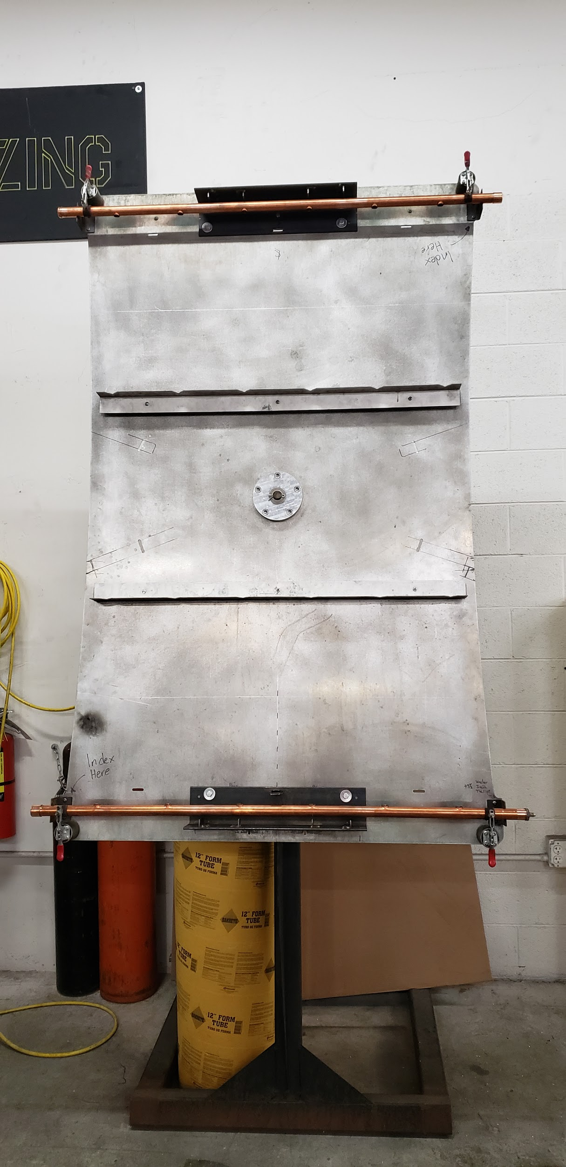

**Figure 5:** Existing 6’ Braze Welding Jig

Although this solution itself can only braze six-foot manifolds, meaning that it doesn’t satisfy the requirement of allowing for variation of sizes. This device is more effective than the table brazing, although fall short of the reengineered device in many ways. The jig was created with a backing of solid aluminum, creating an impediment between the welder and the rear side of the manifold. The device also falls short in that its locking mechanism requires two components and has very few locking positions, compared to the team's final prototype. It has no allowance for multiple jig sizes and its locking of vertical pipes is more resource intensive. Also, the horizontal pipes require multiple clamps to be inserted and secured, when the updated design will consist of a built-in clamping system.

#### 4.2.1.3 Existing Design #3: 8’ Braze Welding Jig

The eight-foot jig is currently Suntrac’s most effective device which was created to reinvent the manifold brazing process. This design is illustrated in figure six below.

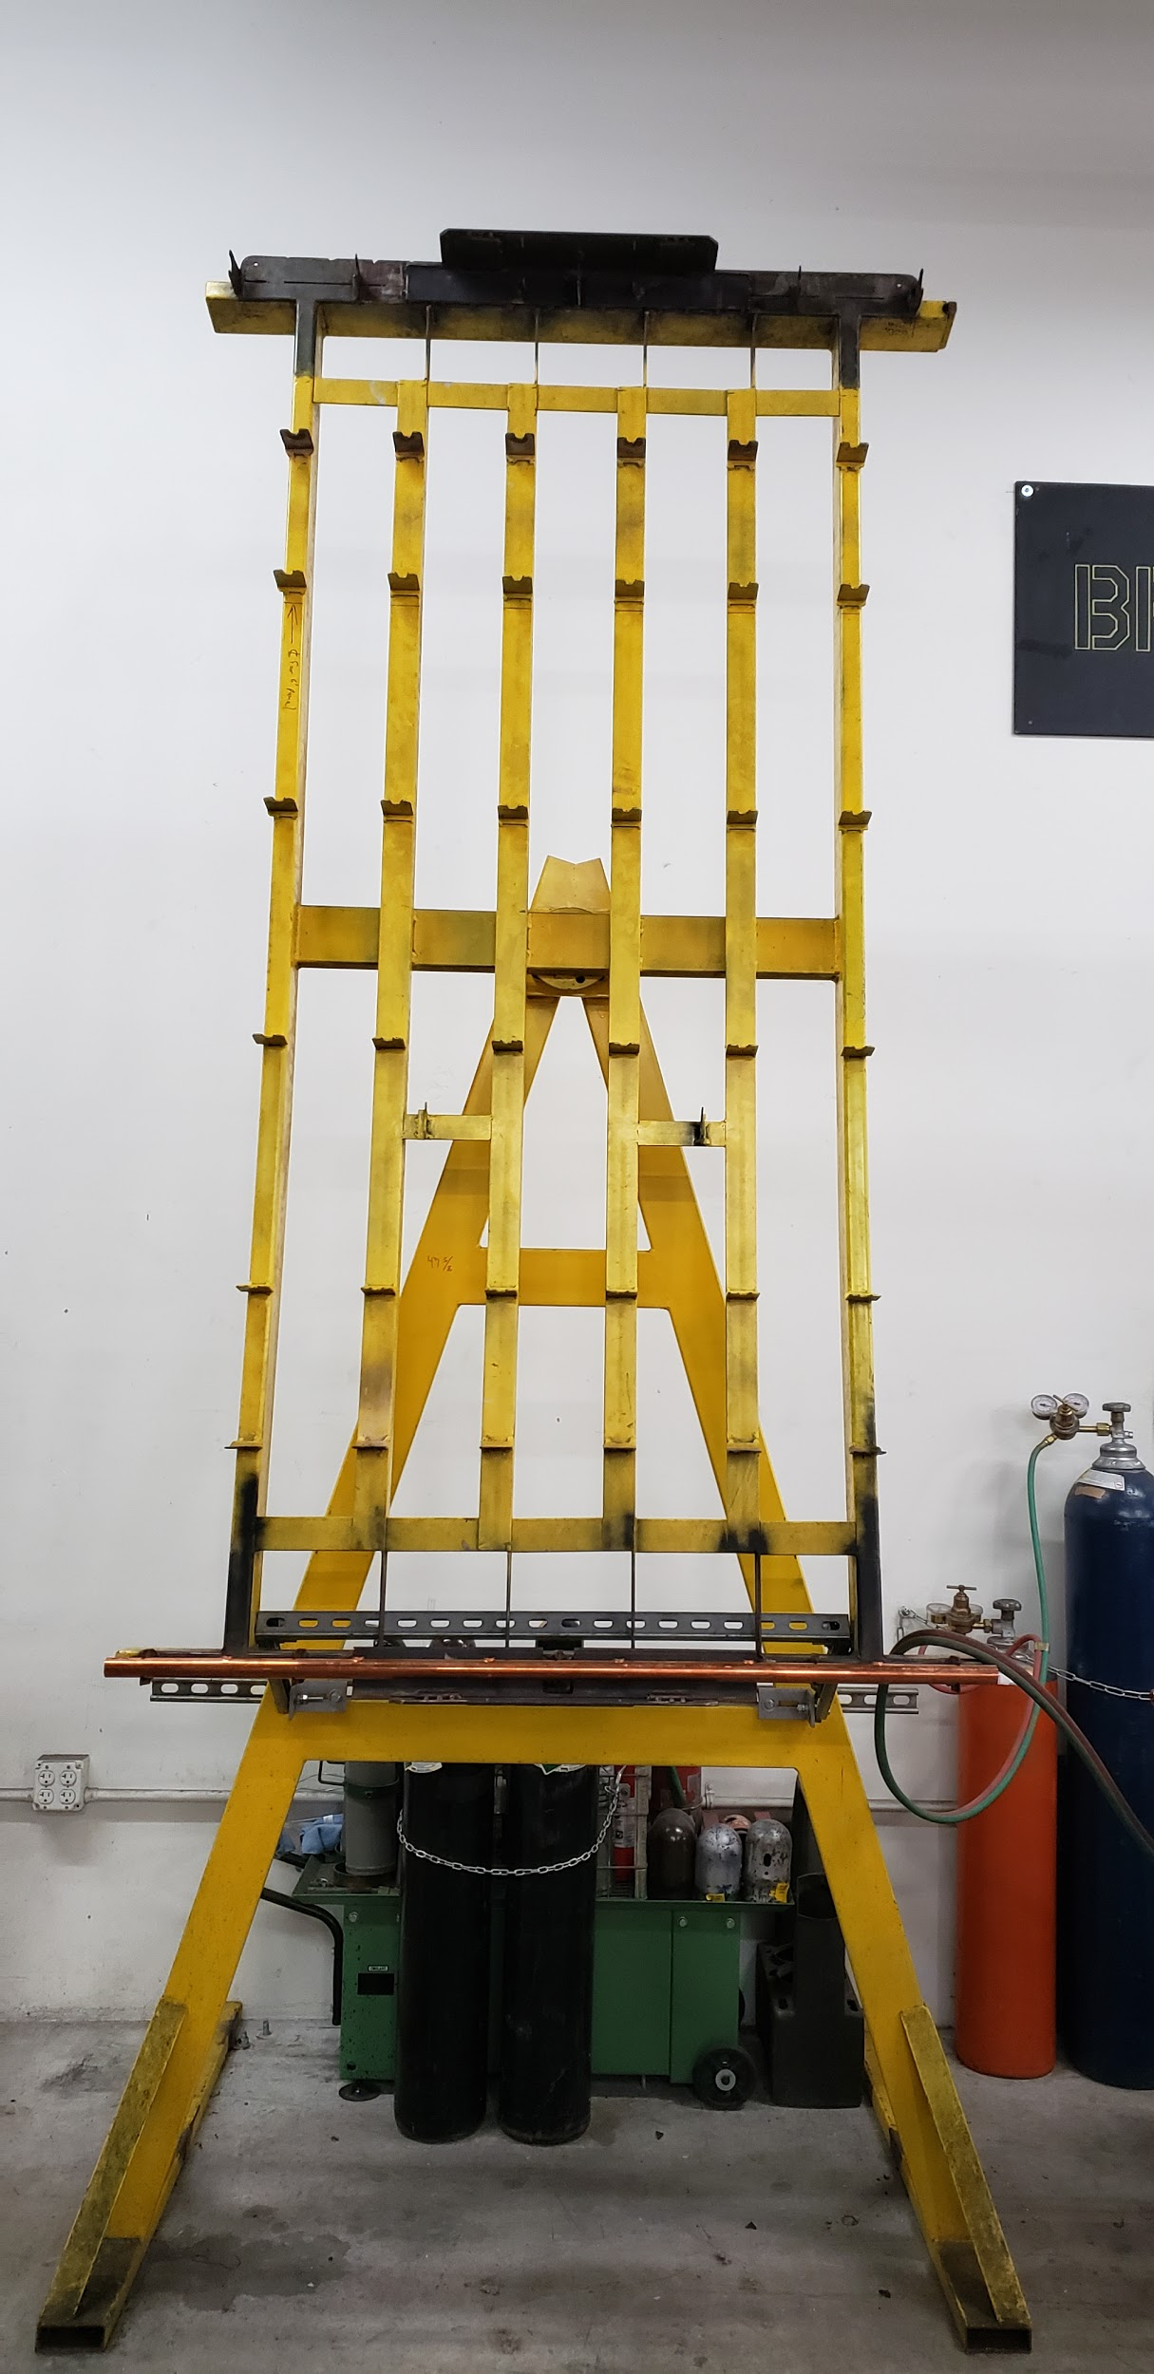

**Figure 6:** Existing 8’ Braze Welding Jig

This device has all the capabilities which the six-foot design has, although it is created with a skeleton frame. This allows for access to the back side of the copper manifolds, although in this design the vertical pipes are positioned directly on the skeletal beams which acts as a minor impediment. The reengineered design implements this effective skeleton frame but offsets the manifold placement to allow for the entire access of all brazing points. This eight-foot design is similar to the six foot in that it requires multiple components to lock the rotating frame and to clamp the horizontal pipes, and it does not allow for variation of manifold size.

### *4.2.2 Subsystem Level Benchmarking*

The subsystem analysis of the team's final design can comprise numerous processes such as frame maneuvering, locking of vertical pipes, locking of horizontal pipes, variable manifold sizing, base structure, frame locking, and bracket securing. This section will emphasize the subsystems of the base structure, frame configuration, and frame lock. The frame configuration consists of a skeleton structure, solid plate, and a wooden table. The base structure existing designs include a bent T, a rectangular beam, and a rectangular solid base. It’s important to highlight that the locking mechanism has only two existing designs as the horizontal table existing design had no ability to maneuver. Within this subsystem there is the locking by pin and swing arm.

#### 4.2.2.1 Subsystem #1: Frame Roto-Locking

Maneuverability for ease of use is a key feature of the reengineered product, although this requires the ability to lock. The solution the team has come up with for maneuvering is to rotate about the centroidal axis, as is two of the existing designs. All locking mechanisms will be regarding the stopping of angular momentum of the skeleton frame design, these mechanisms being a pin and swing arm

##### *4.2.2.1.1 Existing Design #1: Pin Lock*

The method used in the eight-foot existing design is to simply lodge a pin between the frame and the supporting stand behind. This design is simple to recreate, although greatly minimizes the number of locking positions and convenience of the welder. This method also requires having a separate component not connected to the jig itself, expanding on the inconvenience of the user.

##### *4.2.2.1.2 Existing Design #2: Swing Arm Lock*

The locking mechanism utilized by the six-foot jig is a swing arm. Unlike the pin, this device is attached to the supporting structure. Although there is no detriment of an extra detached component, this design still has its shortcomings. This method's implementation on the six-foot jig does not have many locking positions. Although many can be achieved, this would require much material to create contact beams. This expense is not worth the capability in comparison to the gear locking device where it will be costly, although it will result in great convenience.

#### 4.2.2.2 Subsystem #2: Frame Configuration

The aspect of the apparatus which holds all the mechanisms that contacts the manifold is a critical design consideration. This part comprises most of the entire jig, thus maximizing its effectiveness helps to ensure a successful design. The three existing designs to be discussed are the skeleton, solid, and table.

##### *4.2.2.2.1 Existing Design #1: Skeleton Frame*

The design proven to be most effective is the skeleton frame as it allows for the rear access of the copper manifold while still providing support to the vertical pipes. This design can be utilized in three of six parallel supports. The existing eight-foot design uses six beams where each vertical manifold pipe is secured to a beam, this is effective although still acts as an impediment as stated in section 3.2.1.3. The design teams device will use the skeleton frame with three beams because the manifold can be symmetrically offset and accessed from all directions.

##### *4.2.2.2.2 Existing Design #2: Solid Plate Frame*

The use of a solid frame can be seen through Its use in the six-foot jig. This method allows for great stability and tolerance assurance, although it acts as a considerable inconvenience to the welder as the rear side of the copper manifold cannot be accessed during brazing. This method is also resource intensive, and creates a great amount of inertia to overcome when rotating.

##### *4.2.2.2.3 Existing Design #3: Wooden Table*

The frame of the brazing process during Suntracs startup was simply a horizontal table. This frame design is evidently less effective than the others as the welder must move around the manifold to reach certain points. It is less than ideal to be required to navigate around the device with an oxyacetylene torch in one’s hand. This design also comes with the problem of restricting access to the middle of the manifold.

#### 4.2.2.3 Subsystem #3: Base Structure

The base structure is another critical subsystem which is important to design efficiently as it comprises more than half of the mass of the system and provides support for all other components. The three existing designs used by Suntrac are a bent L, square beam, and a solid rectangle base.

##### *4.2.2.3.1 Existing Design #1: Bent T Base*

The bent T base configuration is utilized by the existing eight-foot design. It is called the bent T as from a side view it appears to be an upside-down bent T. This design is effective as it minimizes the warehouse floor space used by the jig with minimal material and has essentially set the requirement of a 5’x5’ footprint.

##### *4.2.2.3.2 Existing Design #2: Rectangular Beam Base*

The rectangular beam base configuration is used by the six-foot design. This design effectively minimizes the floorspace of the jig, while employing very little resources. This method is also easy to manufacture and duplicate. This results in the device being a great consideration during the concept generation aspect of the design process.

##### *4.2.2.3.3 Existing Design #3: Rectangular Solid Base*

The rectangular solid base is employed by the initial method of brazing over a horizontal table. This table had a skeleton top section attached to a solid wooden foundation. This method ensures absolute stability as the foundation is excessively large and resource intensive. This relates to the requirements in that it does not allow for maneuvering of the manifold and doesn’t satisfy the 5’x5’ footprint restriction.

# 

# 5 CONCEPT GENERATION

To generate concepts, the team utilized the gallery method to brainstorm ideas. First, the team generated seven concept variants from the Engineering Requirements. Next, each team member individually came up with two to three sketches for each sub-concept. After finishing the sketches, each team member presented the sketches created. Some concepts were adjusted and others were eliminated.

## 5.1 Full System Concepts

After generating ideas, the team produced seven full system concepts. These full system concepts were called design alternatives. The top three design alternatives were design alternative one, four, and six, therefore they will be discussed in detail in the following sections.

### *5.1.1 Full System Design #1: DA 1 Circular Slides and Swivel Latches*

The first design alternative that will be discussed uses circular pipes that are locked by pins to adjust the height of the jig. To rotate the jig, a foot pedal is connected to a gear that locks it into place. When the foot pedal is pressed, the gear is released thus causing rotation. To lock the jig in place, the base is being bolted to the ground. To keep the vertical pipes from moving, U-shaped brackets are used, and to keep the horizontal pipes from moving, swivel latches are used on either end. Finally, to keep the brass brackets locked, an indented surface is used with a slider that slips on top of the bracket thus keeping it in place. Figure seven is a sketch of a design alternative one.

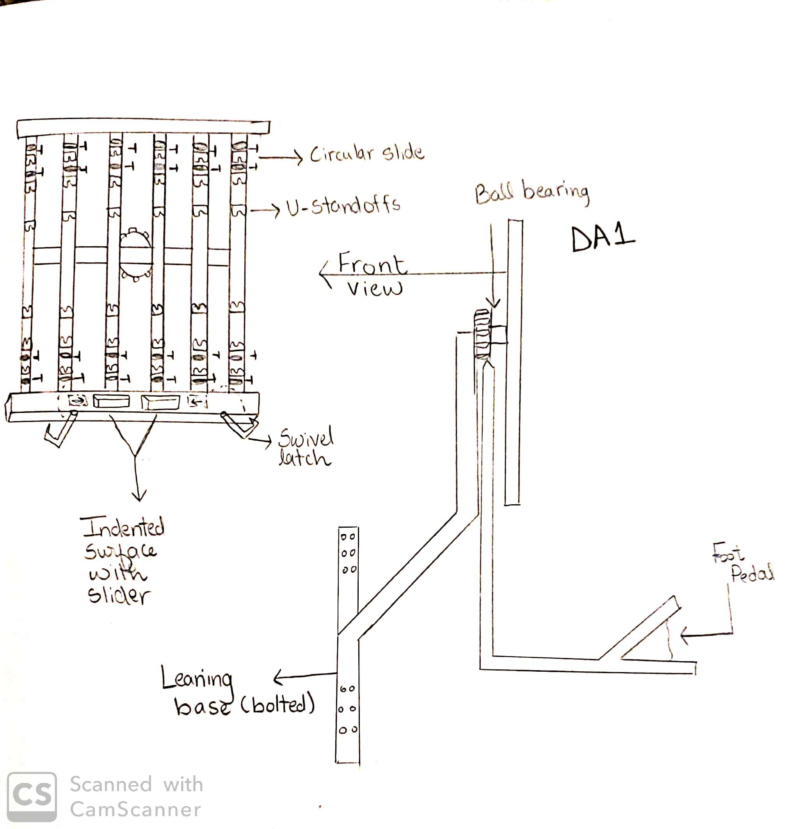

**Figure 7:** Design Alternative 1

As seen in Figure seven, the front view of the jig shows where the features discussed are being placed on the skeleton of the jig. It also shows the location of the foot pedal mechanism and where the device is being bolted to the ground. This design is beneficial as it will require a minimum amount of force to rotate and lock the jig in place. Another pro to using this design is that it uses round pipes for the skeleton which is easier to handle when assembling the jig. Although using round pipes is beneficial for assembly, it weakens the device making it less durable and stable thus allowing more space for error. Also, bolting the design to the ground requires more footprint than bolting it to the wall which is another con to this design.

### *5.1.2 Full System Design #2: DA 4 Rectangular Slides and Power Screws*

The second design alternative that will be discussed uses rectangular slides to adjust the height of the jig. Pins will be used to lock the apparatus from moving in the vertical direction. For rotation, the same concept will be used from design alternative one where a gear is being locked by a foot pedal which controls the rotation of the device. In this design, the jig will be bolted to the wall instead of the ground to lock it in place. Moreover, to keep the vertical pipes from moving, the same U-bracket standoffs are used and for locking the horizontal pipes, a pad is oriented at either end of the jig where a power screw locks it to keep the pipes in place. Lastly, for locking the brass brackets, the same idea is used from the design alternative one by which an indented surface with a slider keeps the bracket in place. Figure eight is a sketch of design alternative four.

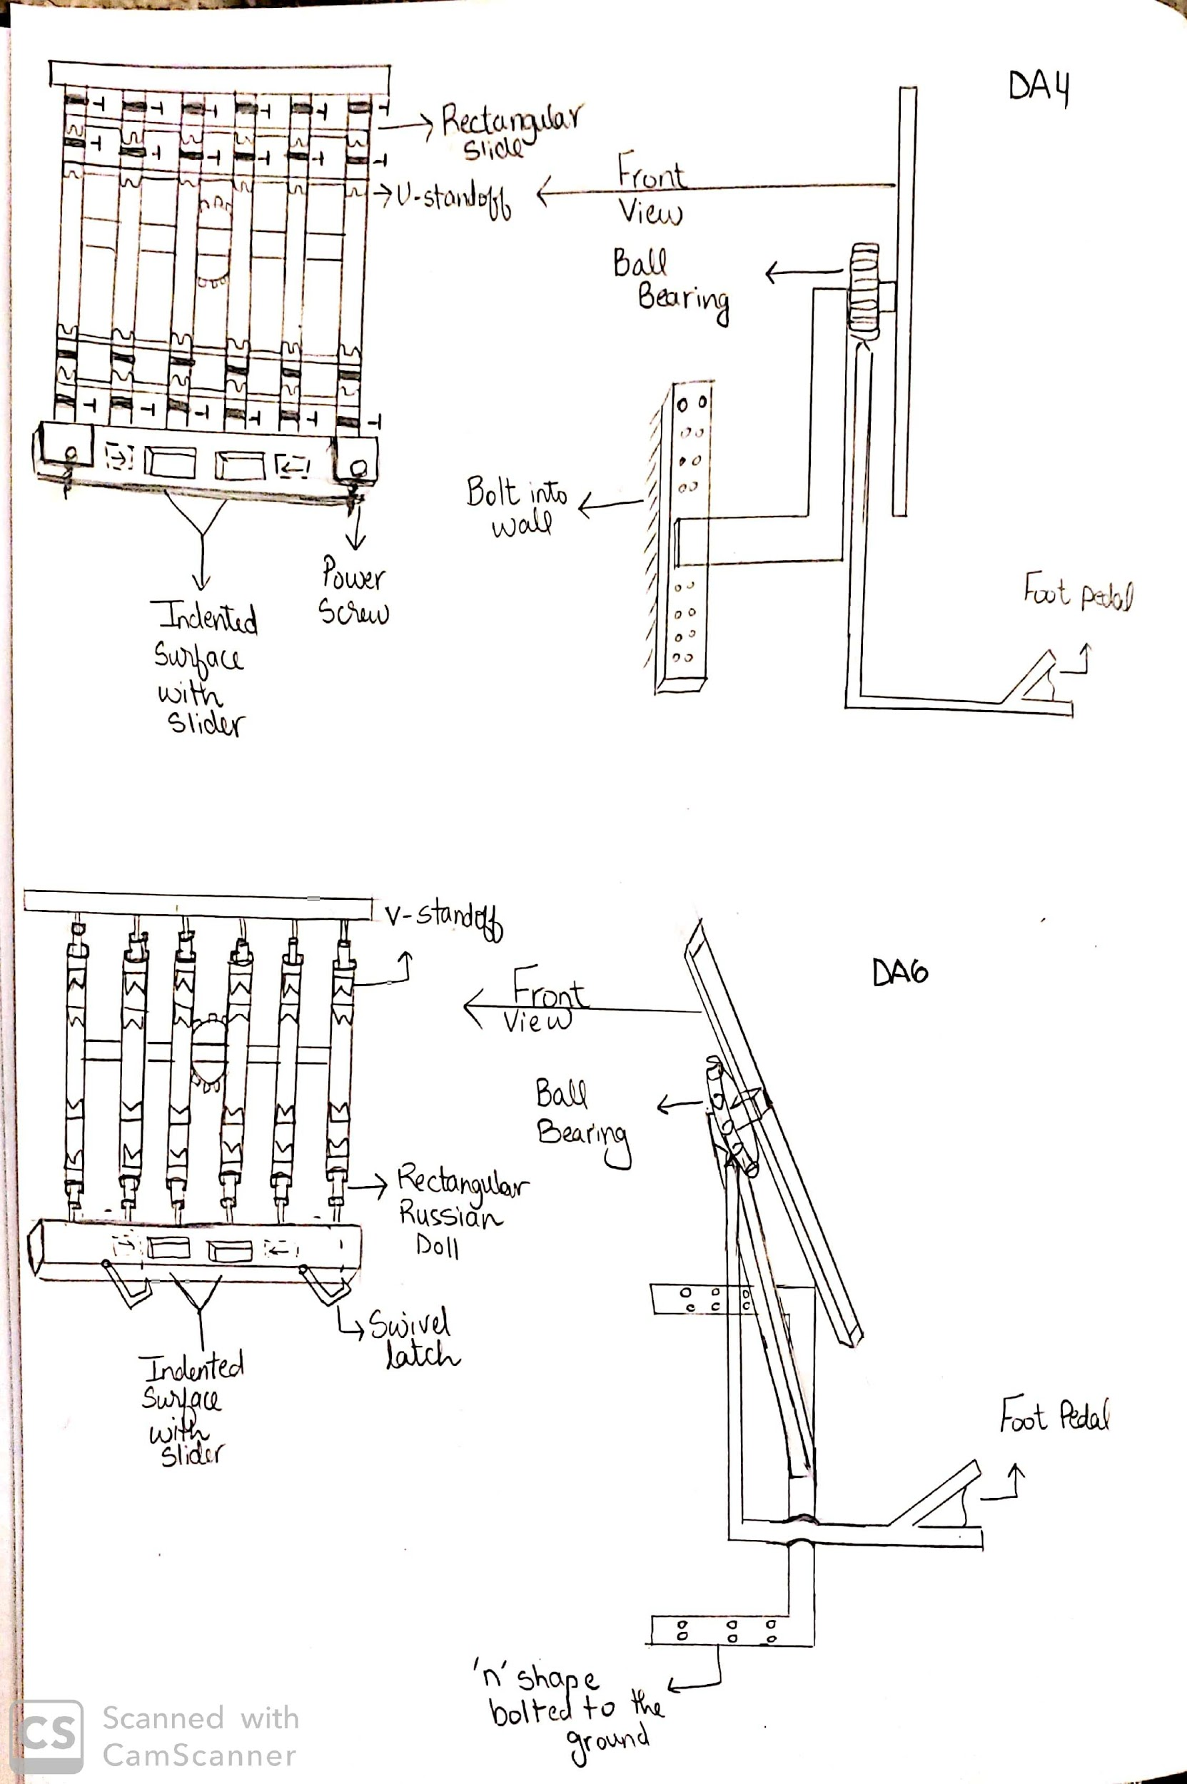

**Figure 8:** Design Alternative 4

Figure eight shows design alternative four’s sub-functions in a front view. It also shows a side view of the device representing the location of the foot pedal and where the device is bolted. The pros of using this device are less footprint space, minimum amount of force to rotate the device, and rectangular slides are rigid. This device takes less footprint space because it is bolted to the wall and since it uses the same pedal mechanism it will require a minimum amount of force to rotate and lock the jig. Also, since the skeleton of this design is rectangular and not circular, it will offer more stability and durability. On the other hand, rectangular slides require more effort to assemble than circular, and bolting the device to the wall restricts the client on where to place the device.

### *5.1.3 Full System Design #3: DA 6 Rectangular Slides and Swivel Latches*

The third design alternative that will be discussed also uses rectangular slides to vary the height of the jig and pins to lock the slides in place. For rotation, this design also uses the foot pedal mechanism and to lock the device in place, a base with the shape of the letter “n” is being bolted to the ground. In addition, this design uses v-bracket standoffs to keep the vertical pipes from moving and swivel latches for the horizontal pipes. The same indented surface with a slider will be used for locking the brass brackets as in the previous two designs. The sketch of design alternative six can be seen in figure nine.

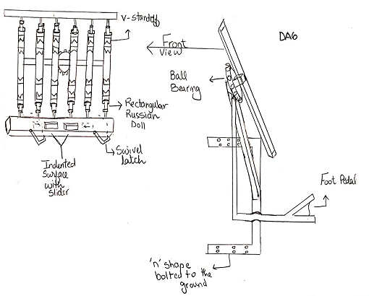

**Figure 9:** Design Alternative 6

From figure nine, the features that make up design alternative six can be seen in a front and side view. This design is similar to design alternative four in figure eight with some minor changes. The pros to using this design are the minimum amount of force to rotate, rectangular slides are rigid, and v-standoffs. The design requires a minimum amount of force due to the foot pedal mechanism and having rectangular slides make the device stable and durable. Moreover, using v-standoffs instead of u-standoffs is a pro since pipes expand while being welded and having the bracket shaped as a v will reduce the chance of the pipes sticking to the brackets. The cons to using this design is that it will require more footprint space as it will be bolted to the ground and the rectangular slides will take more effort to assemble.

## 

## 5.2 Subsystem Concepts

The team had originally come up with seven different concept variants or subsystem concepts which are maneuvering the jig, locking jig, locking vertical pipes, locking horizontal pipes, adjusting size, standing upright, and locking brass brackets. After brainstorming ideas, the team combined the subsystems maneuvering the jig and locking the jig since they have to be used together.

### *5.2.1 Subsystem #1: Maneuvering and Locking the Jig*

This subsystem combines maneuvering the jig and locking it because the design to maneuver the jig has to be compatible with the design to lock it. This subsystem satisfies the need to adjust orientation found in the functional decomposition in Figure #. It is also one of the major requirements the client discussed when benchmarking.

#### 5.2.1.1 Design #1: Ball Bearing Pivot With Foot Pedal Lock

Design one utilizes a foot pedal to rotate the jig. When the pedal is pressed it releases a gear that is attached to a ball bearing. After the gear is released it will rotate until the pedal locks it again. This design will be attached to the skeleton of the gear. Figure ten is a sketch of the foot pedal mechanism.

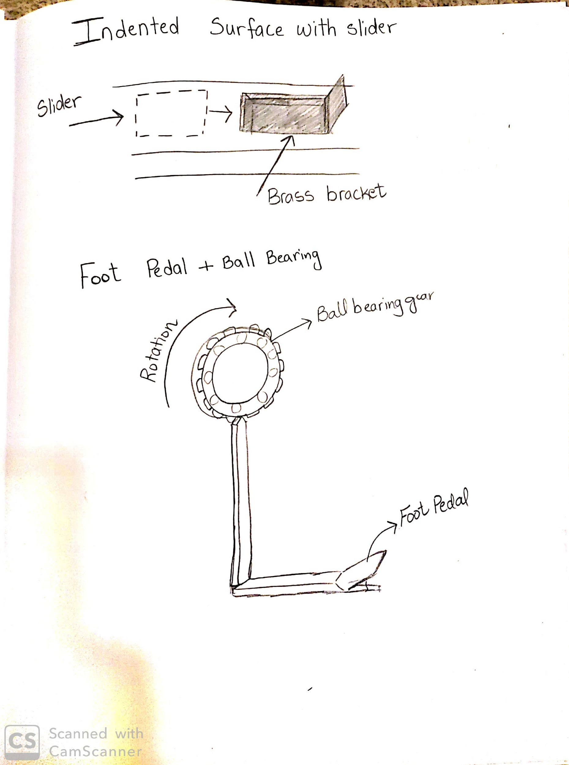

**Figure 10:** Foot pedal mechanism

The pros to the design in figure ten is that it is easy to use, does not require a great amount of force, and it only takes a few seconds to maneuver the jig. The only con to this design is that it might be a safety hazard since it is positioned on the ground and could cause tripping.

#### 5.2.1.2 Design #2: Ball Bearing and Pull Handle Lock

This design is similar to design one in which it uses the idea of the ball bearing gear to rotate the jig. When the handle is pulled, the gear is released thus causing rotation. To lock the jig, the handle goes back to its original position. This design would be located behind the skeleton of the jig. Figure 11 is a sketch of the design.

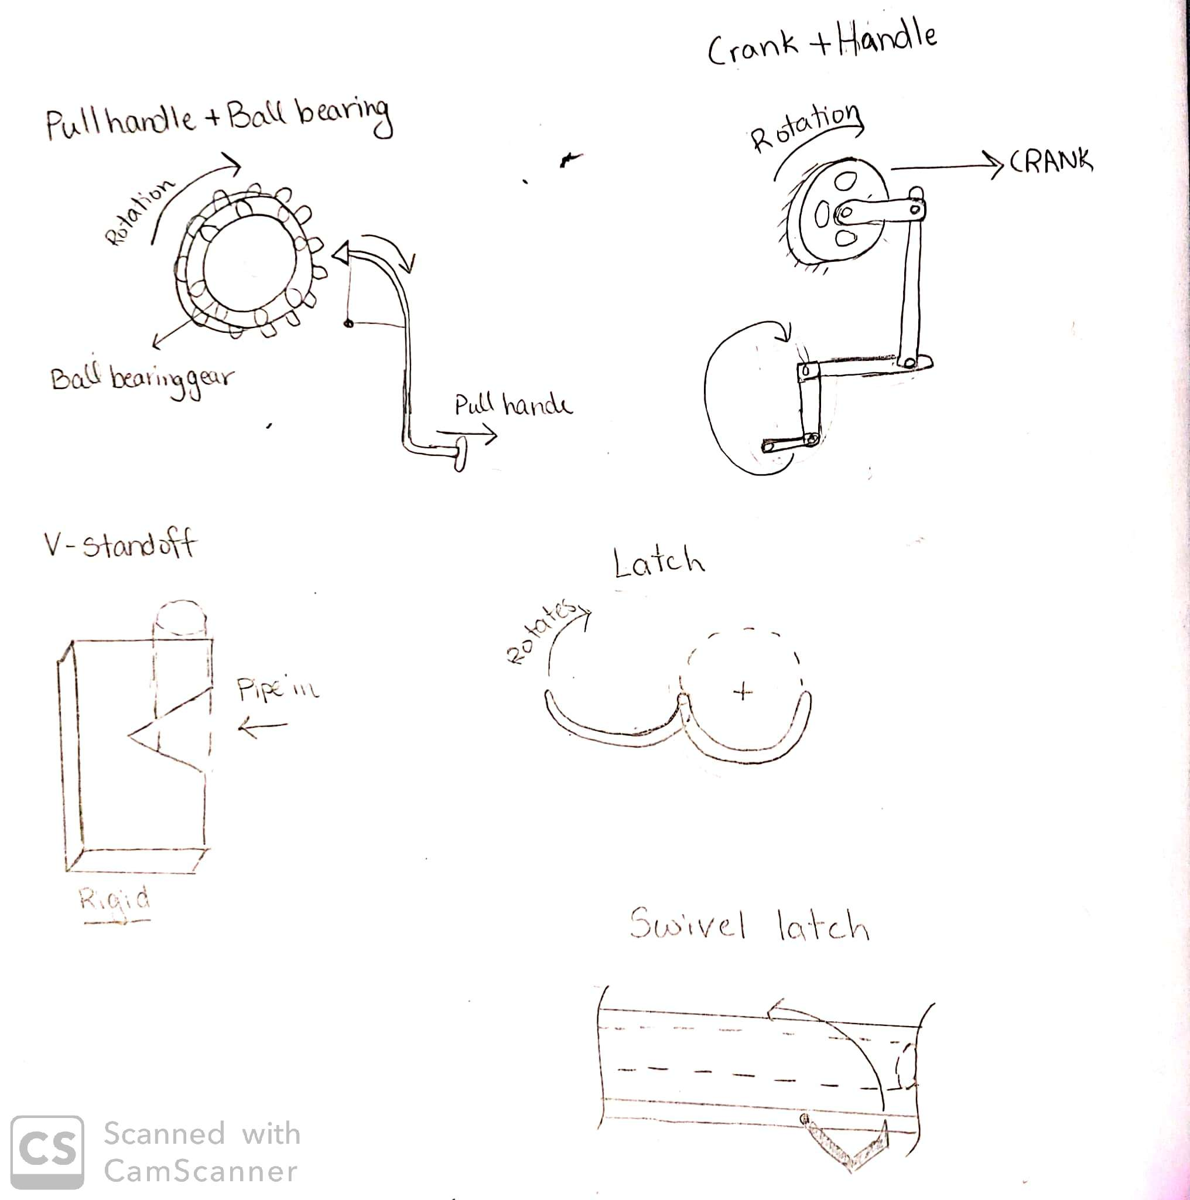

**Figure 11:** Pulling mechanism

Using the design in figure 11 has two pros, the first is that it is easy to handle and the second is that it does not require a huge amount of force to rotate the jig. A con to using this design is that it will require the user to move to the back of the jig to access the handle. Therefore, it will require more footprint space for each jig to account for the accessibility of the handle.

#### 5.2.1.3 Design #3: Crank Handle

This design uses a crank and a handle to rotate the device. The crank will be located behind the skeleton of the jig. To use this design, the user will need to access the handle and spin it to cause rotation on the crank. The schematic of this design is found in figure 12.



**Figure 12:** Crank mechanism

Figure 12 shows the crank mechanism of design three. The pro to using this design is that it is easy to handle since it only requires the handle to be spun. However, this design is poor because it will require a crank that can withstand a great amount of force to rotate the jig and since it is attached to a handle that is accessible from the back it will require more footprint space to account for the handle’s accessibility.

### *5.2.2 Subsystem #2: Locking Vertical Pipes*

This subsystem ensures the vertical pipes are locked in place while the manifold is being welded. The designs under this subsystem should keep the pipes from tilting left or right. Another use of this subsystem is to hold the Teflon rings from moving while the manifold is being welded since they are attached to the vertical pipes. This subsystem satisfies the position and secure components in the functional decomposition.

#### 5.2.2.1 Design #1: U-standoff

This design will be brazed on the skeleton of the jig to lock the vertical pipes in place. It will also keep the Teflon rings from sliding to the bottom of the pipes where they are welded. Figure 13 is a sketch of u-standoff design.

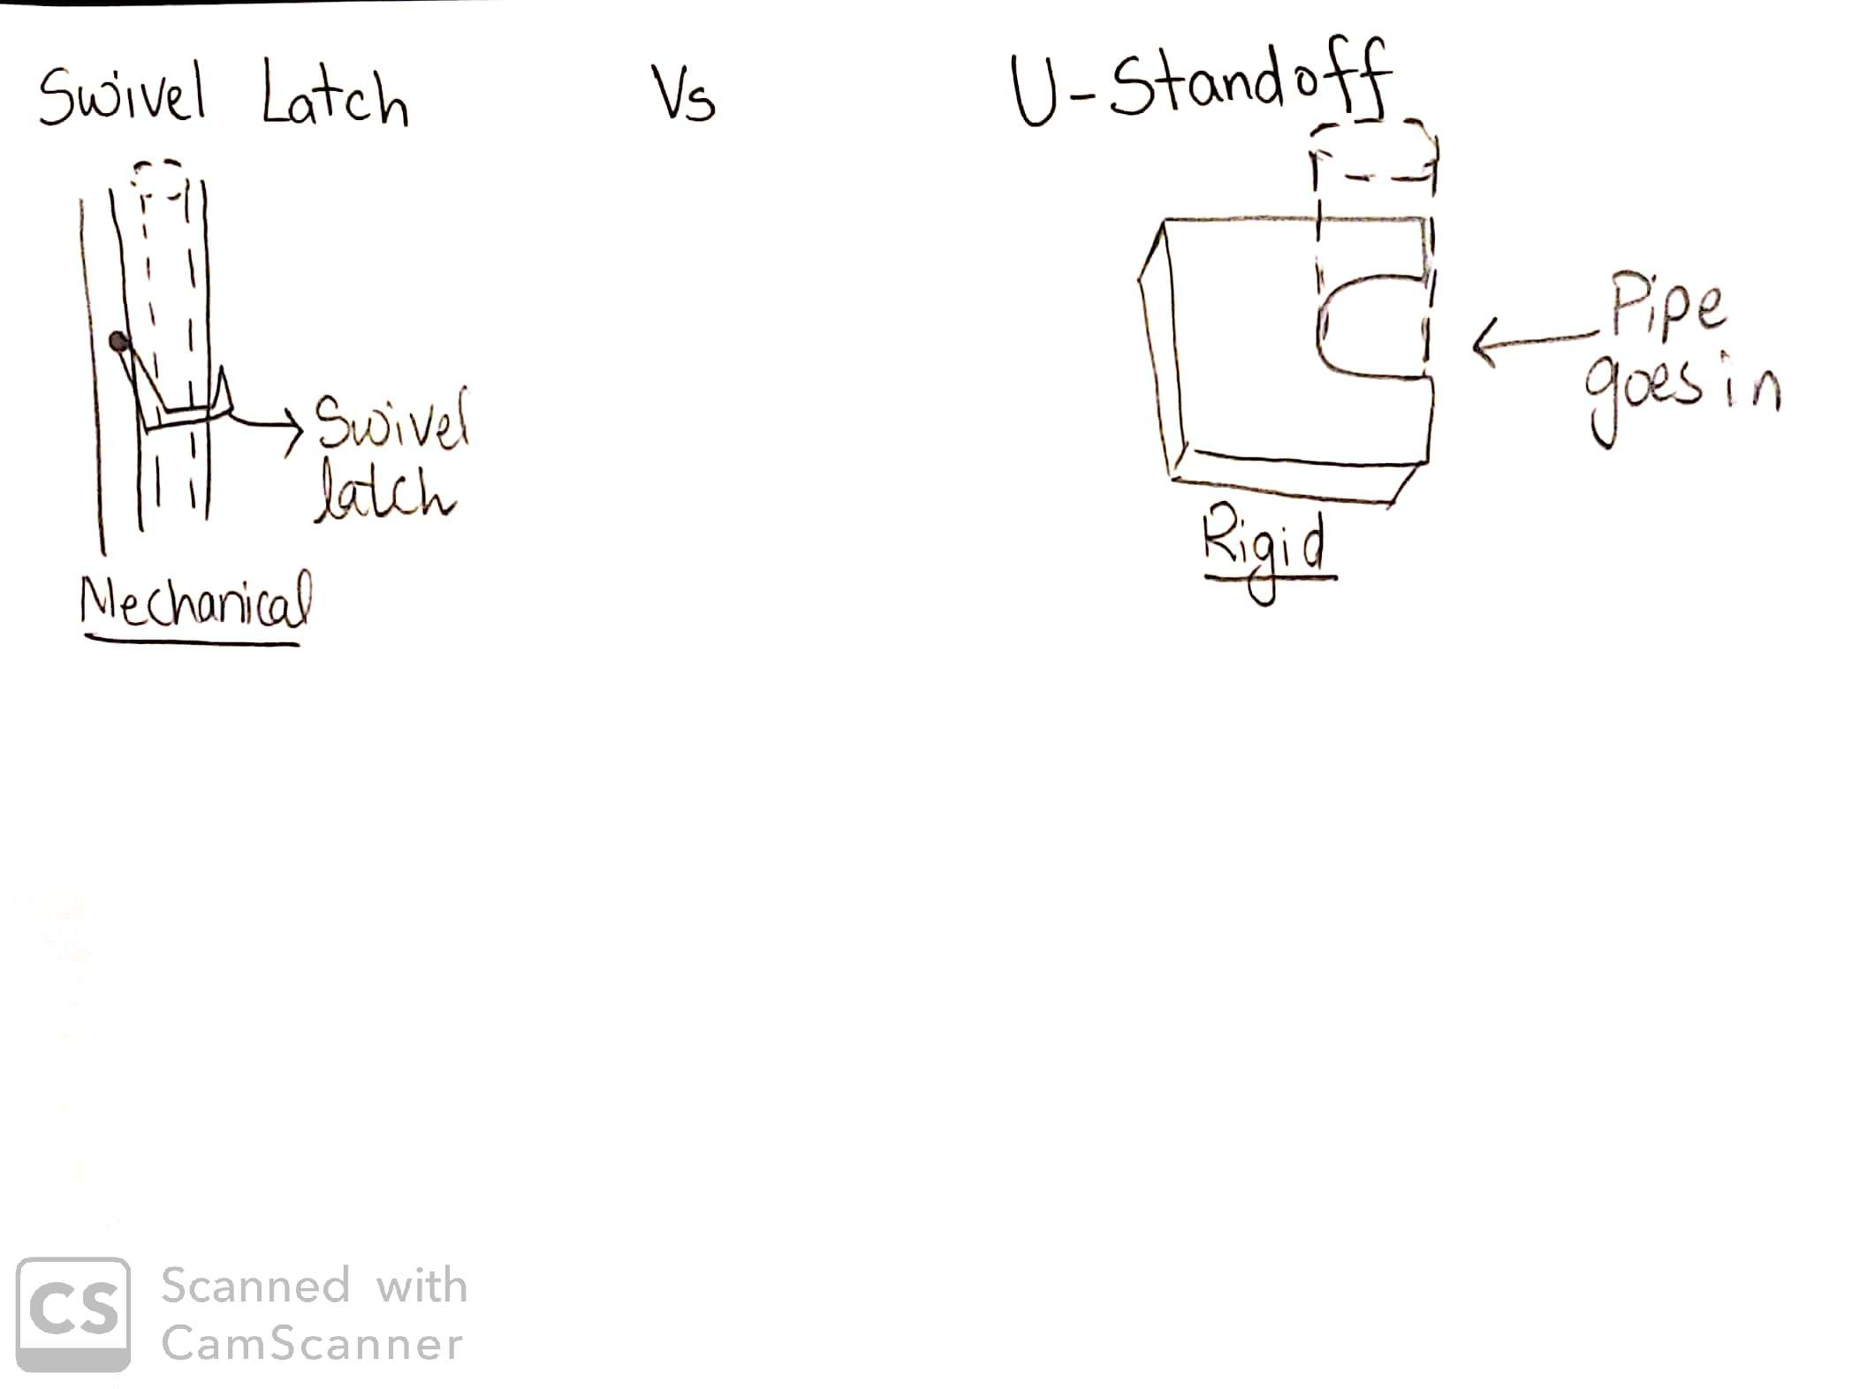

**Figure 13:** U-standoff

In figure 13, the u-standoff sketch shows where the pipe will be positioned within the bracket. The pro to using this design is that it is a rigid piece so it will be easy to manufacture and the con is that the copper pipes could expand when they are being brazed and stick to the walls of the standoff.

#### 5.2.2.2 Design #2: V-standoff

This design is very similar to design one except for the fact that it is shaped as a “v” instead of a “u”. Therefore, it uses the same idea to lock the vertical pipes and the Teflon rings in place. These brackets are positioned on the vertical bars of the jig. The sketch of this design can be seen in figure 14.

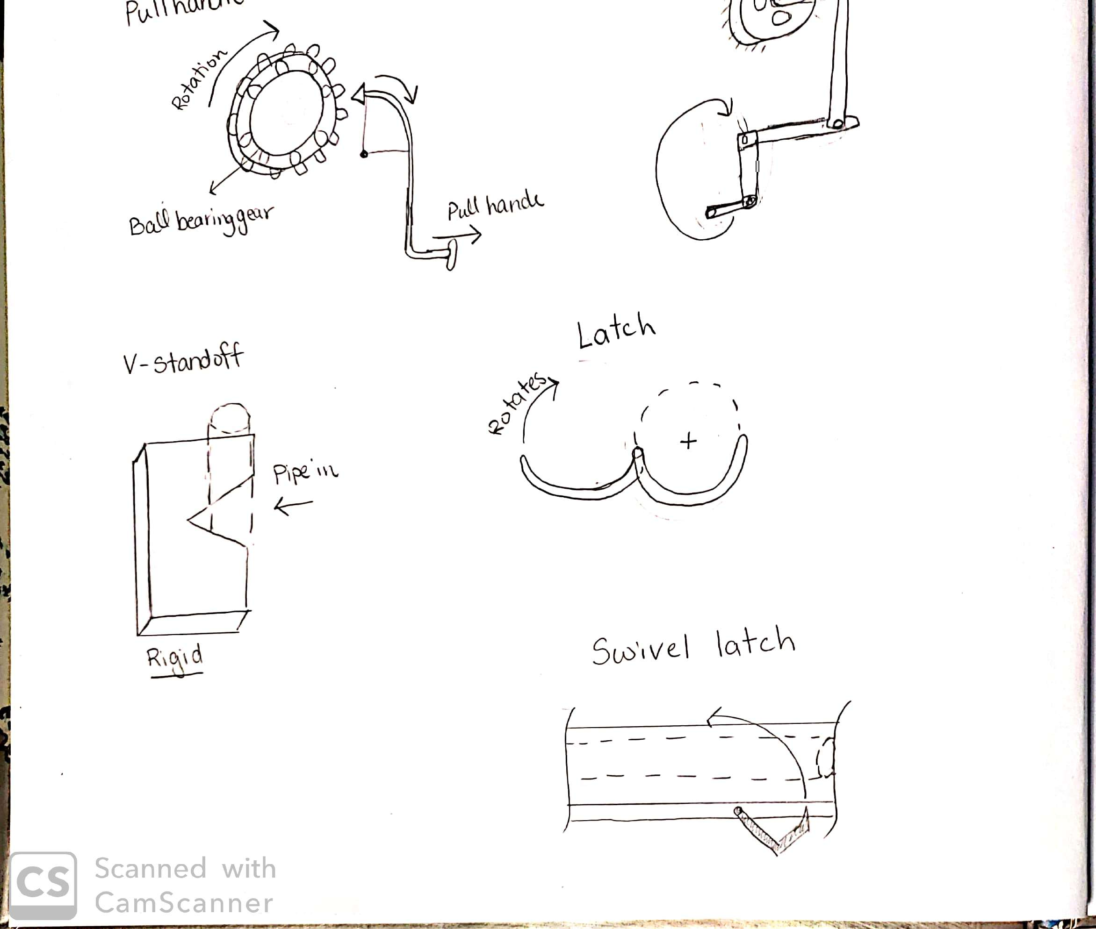

**Figure 14:** V-standoff

The v-standoff in figure 14 is a rigid piece therefore one of its pros is that it is easy to manufacture. Another pro is that the v-shaped bracket minimizes the chance of the pipe sticking to the walls of the bracket when the pipes face heat expansion. The only con to using this design is that the pipes could not be secured properly if the bracket has a tolerance error from manufacturing.

#### 5.2.2.3 Design #3: Latch

This design will be welded on the vertical bars of the jig. It has a latch that rotates and locks the vertical pipes in position. The latch design will also hold the Teflon rings from sliding down the pipe frame. Figure 15 shows a sketch of the latch.



**Figure 15:** Latch

The latch design in figure 15 secures the pipes in all positions which is one of its pros. It is also easy to use and handle. However, since the jig will require multiple latches on each vertical bar to hold the vertical pipes, it will require more time to release the manifold after it is brazed which is a downfall for this design.

### *5.2.3 Subsystem #3: Locking Horizontal Pipes*

This subsystem is similar to subsystem two with the difference of locking the horizontal pipes instead of the vertical ones. The horizontal pipes will be welded to the vertical pipes on one side and two brass brackets will be welded on the other side, therefore the designs of this subsystem should ensure the pipes are held in position from all directions. This subsystem satisfies the position and secure components in the functional decomposition.

#### 5.2.3.1 Design #1: Swivel latch

This design is similar to the latch design from subsystem two. The only difference is the location of the latch on the jig. This latch will be located on the horizontal bars of the jig. When the latch rotates it will lock in place thus securing the horizontal pipes. A sketch of the swivel latch is presented in figure 16.



**Figure 16:** Swivel latch

A pro to using this design is that it is easy to handle and use since it has only one component that needs to rotate as seen in figure 16. A con to using this design is that the latch could expand when the pipes are welded since its position is close to the welding area. When the latch expands it could be harder to release the pipes thus possibly damaging the manifold.

#### 5.2.3.2 Design #2: Power Screw

The power screw concept variant is intended to lock the horizontal pipes by clamping them using increased force output with a screw. This is seen in figure 17.

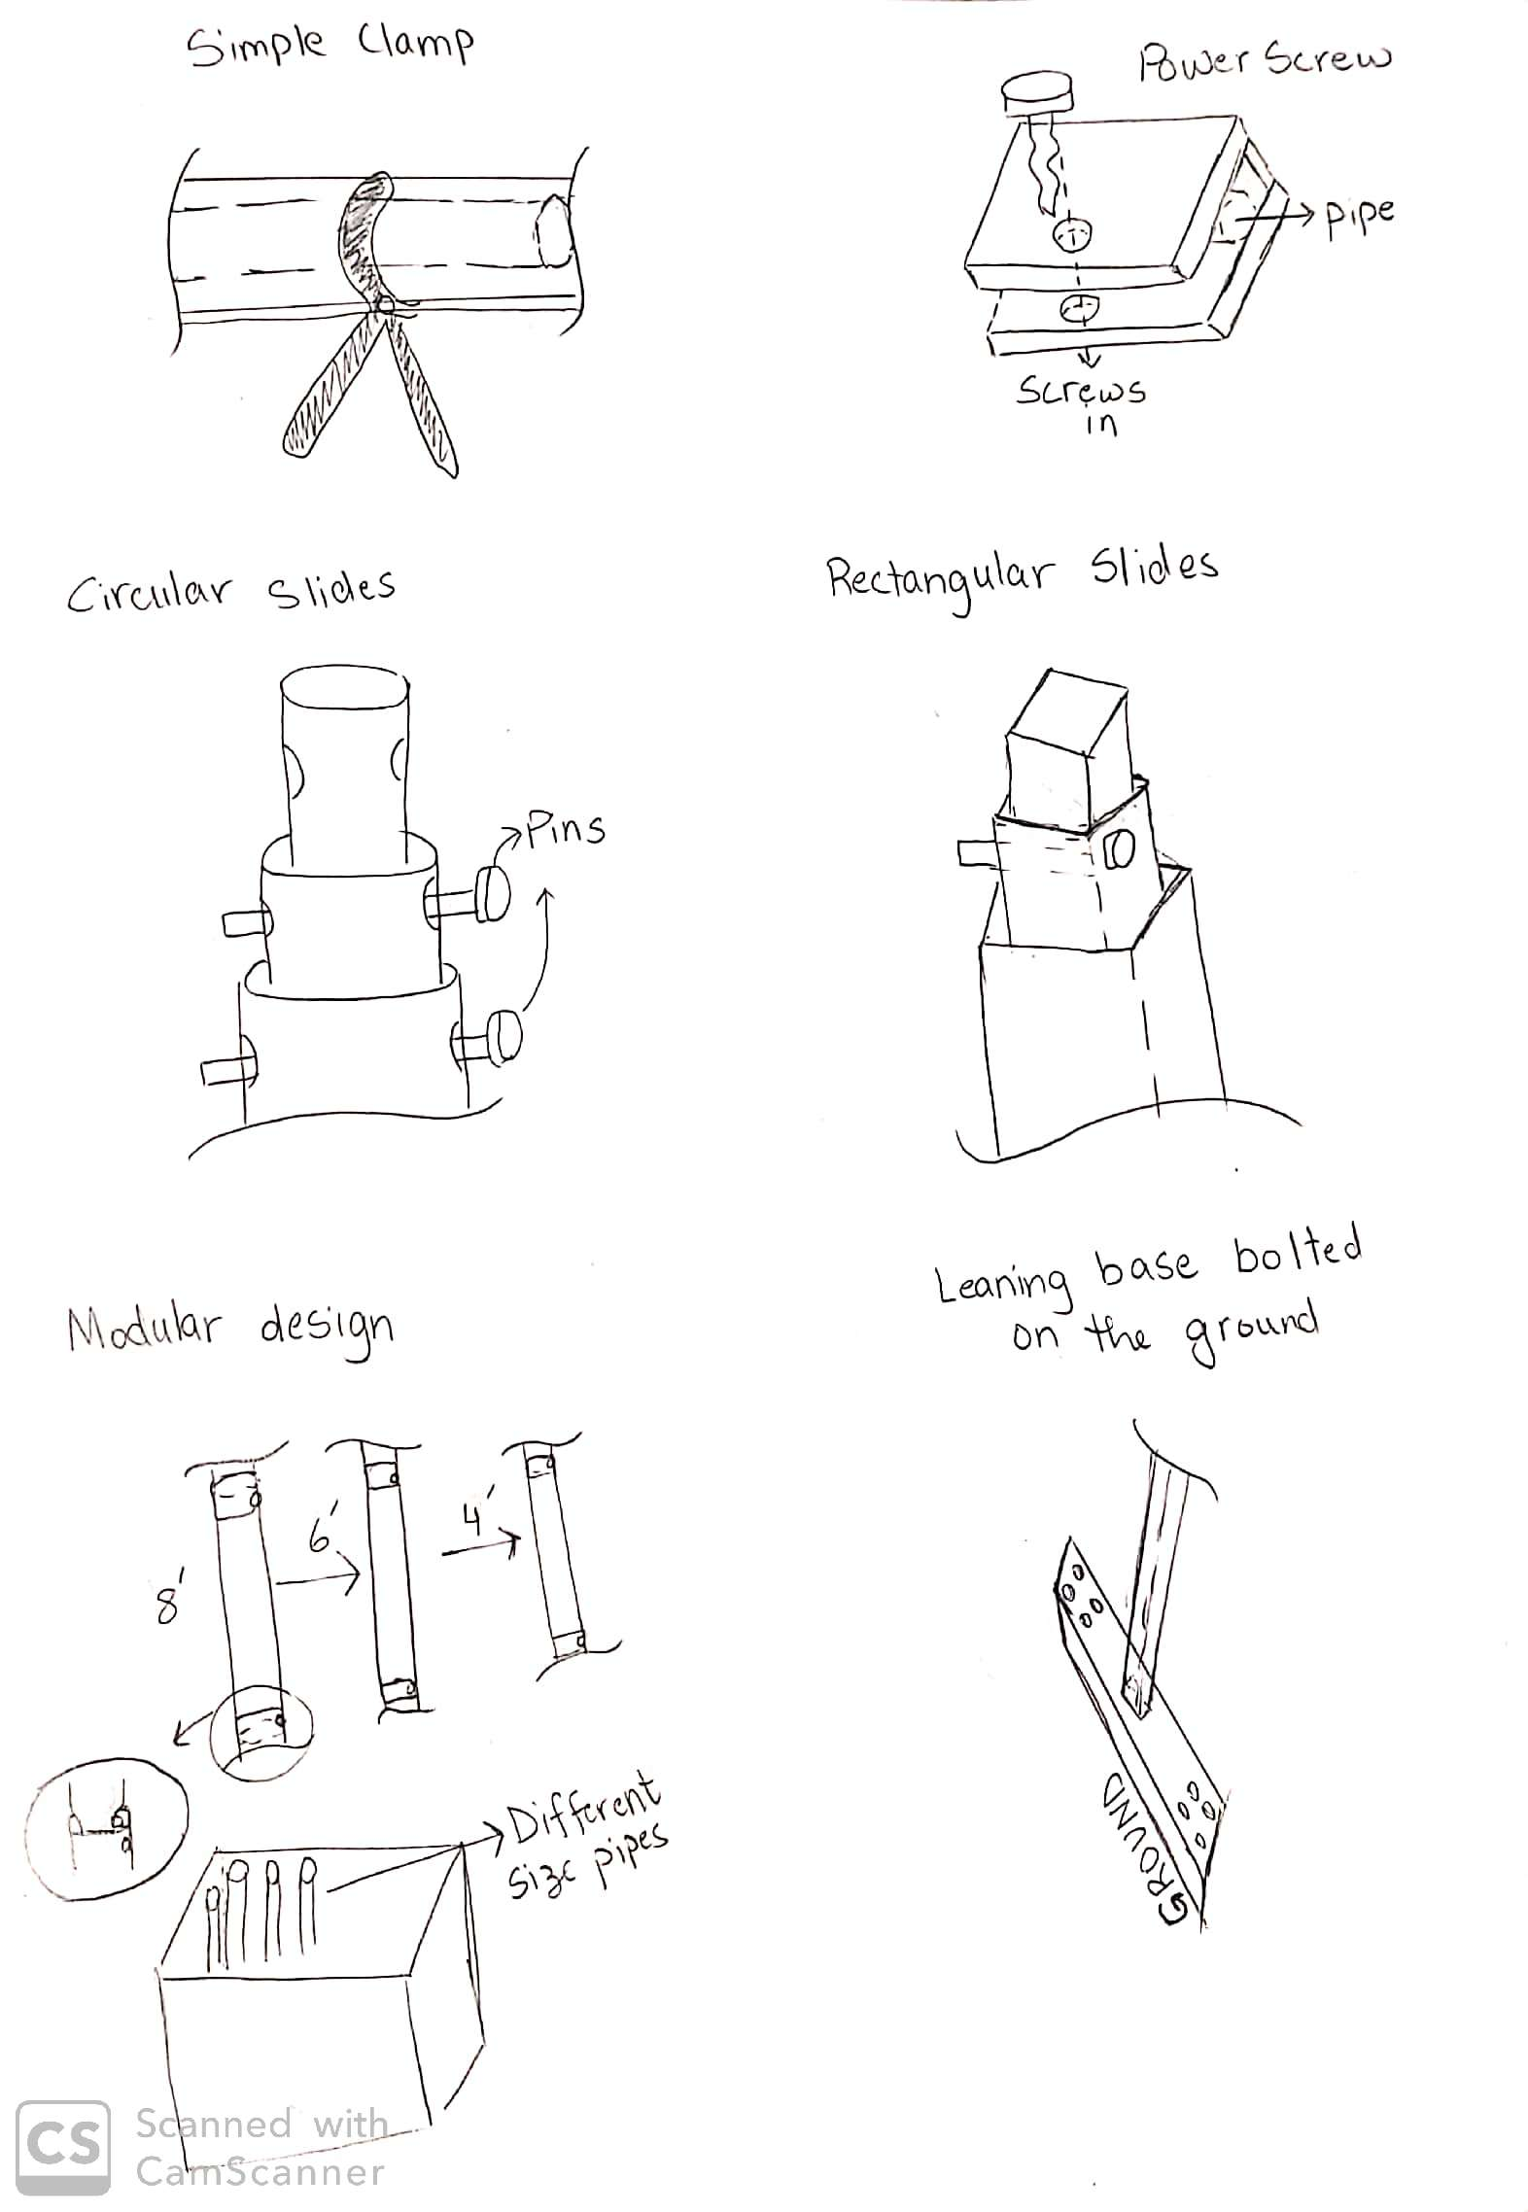

**Figure 17:** Power screw

This design is a relatively effective one. It is rugged and guaranteed to hold the copper pipes in place so the pipes falling out and being a safety hazard is not an issue. The con is that power screws open and close the apparatus slowly

#### 5.2.3.3 Design #3: Simple Clamp

The simple clamp is intended to secure the horizontal copper pipes in place. This involves an external clamp that would be placed by the user and latched on. Figure 18 shows a sketch of the simple clamp.



**Figure 18:** Simple clamp

The pro to this design is that it is quick and easy to use while still being strong enough to hold on to the pipe. There are few cons though, this is a little more expensive than the other existing designs, also since it is applied and removed quickly there may be some sacrifice of accuracy in the manifold. Finally, it can be potentially knocked off while in use.

### *5.2.4 Subsystem #4: Adjusting Size*

This subsystem allows the client to adjust the height of the jig into three different sizes, a 4 foot, 6 foot, and 8 foot. The designs for this subsystem must be able to adjust the size of the jig within a maximum of one hour. Moreover, this subsystem satisfies one of the major goals of the project and benchmarking.

#### 5.2.4.1 Design #1: Circular Slides

This design utilizes circular pipes that slide on top of each other to adjust the jig height. The pipes are locked in the position needed by using pins. The sketch of the design is found in figure 19. These elongations will be used on both ends of the skeleton frame.



**Figure 19:** Circular slides

A pro to using the design in figure 19 is that it is easy to assemble and lock and since it will be located on both ends of the jig instead of one it will reduce the chance of the slides tilting. A con to this design is its durability since the weight of the jig is only being held by the pins.

#### 5.2.4.2 Design #2: Rectangular Slides

This design utilizes rectangular collapsible pipes that will fit inside another to allow the three-size manifold configuration. This design is seen in figure 20. Like the circular slide these will also be locked in place using pins.



**Figure 20:** Rectangular slides

Some pros to this design or that the jig apparatus will be rigid and durable. However, the extra material will make the frame heavier and harder to manage, as well as increased raw material cost.

#### 5.2.4.3 Design #3: Modular Design

This very impractical design utilizes multiple compatible sections to be dismantled and installed during each manifold size variation. This is illustrated in figure 21 below.

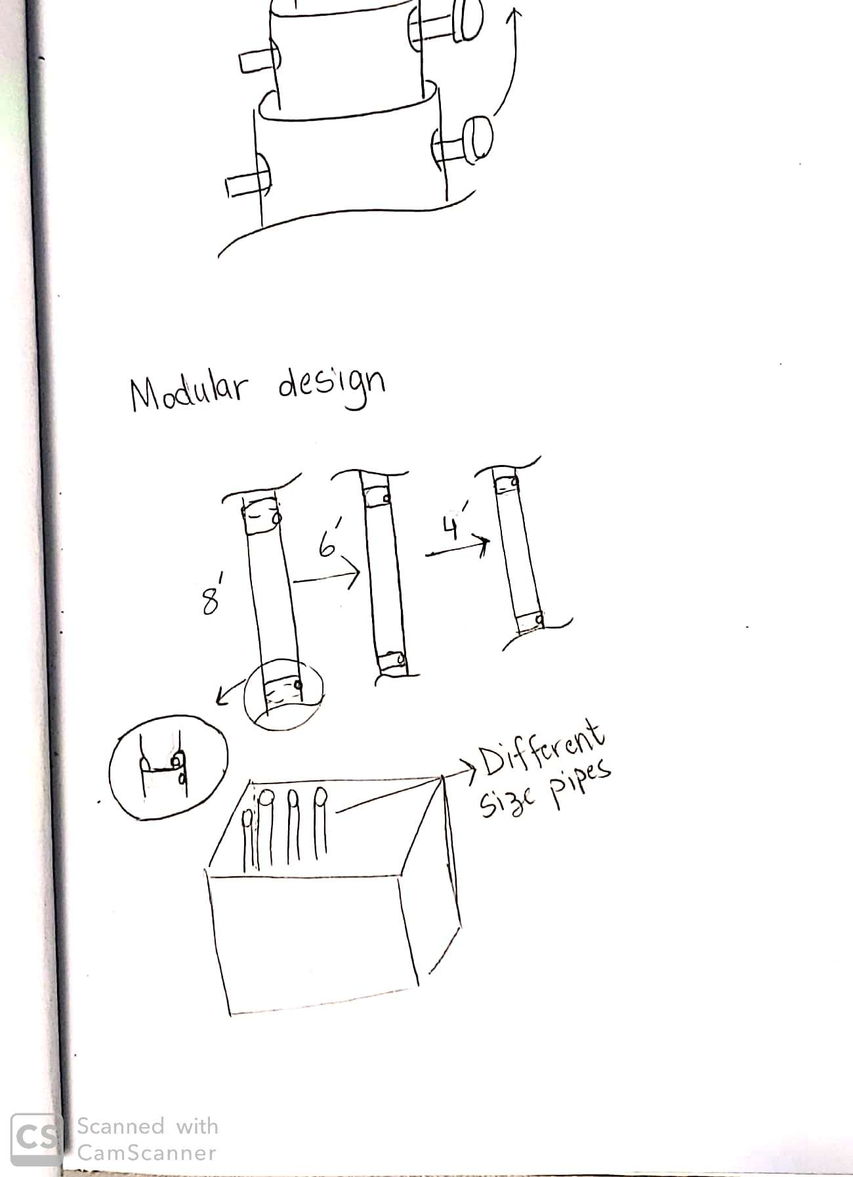

**Figure 21:** Modular design

The only pro for this design is that it does allow for manifold size variation. All together the design is very impractical and has many cons such as inconveniencing the user as it requires much physical effort. The dismantling of these product components creates an increased part count and uses more warehouse space.

### *5.2.5 Subsystem #5: Standing Upright*

This subsystem requires designs that help the jig stand upright thus producing the base of the jig. The designs created for this subsystem also account for footprint space since the jig will be bolted in SunTrac facilities.

#### 5.2.5.1 Design #1: Leaning Base Bolted to the Ground

This design uses a straight bar that is bolted to the ground. The frame of the jig will be attached to the straight base in an angle. Figure 22 shows the orientation of the base.



**Figure 22:** Leaning base bolted on the ground

The design in figure 22 is basic therefore its only pro is that it is easy to bolt on the ground. The con to using this design is that it will require a wide space thus occupying more footprint.

#### 5.2.5.2 Design #2: Bolted into the Wall

This design is similar to design one however the difference is that it is being bolted to the wall. Likewise, the frame of the jig will also be attached to the base in an angle. Figure 23 provides a sketch of the design being bolted to the wall.

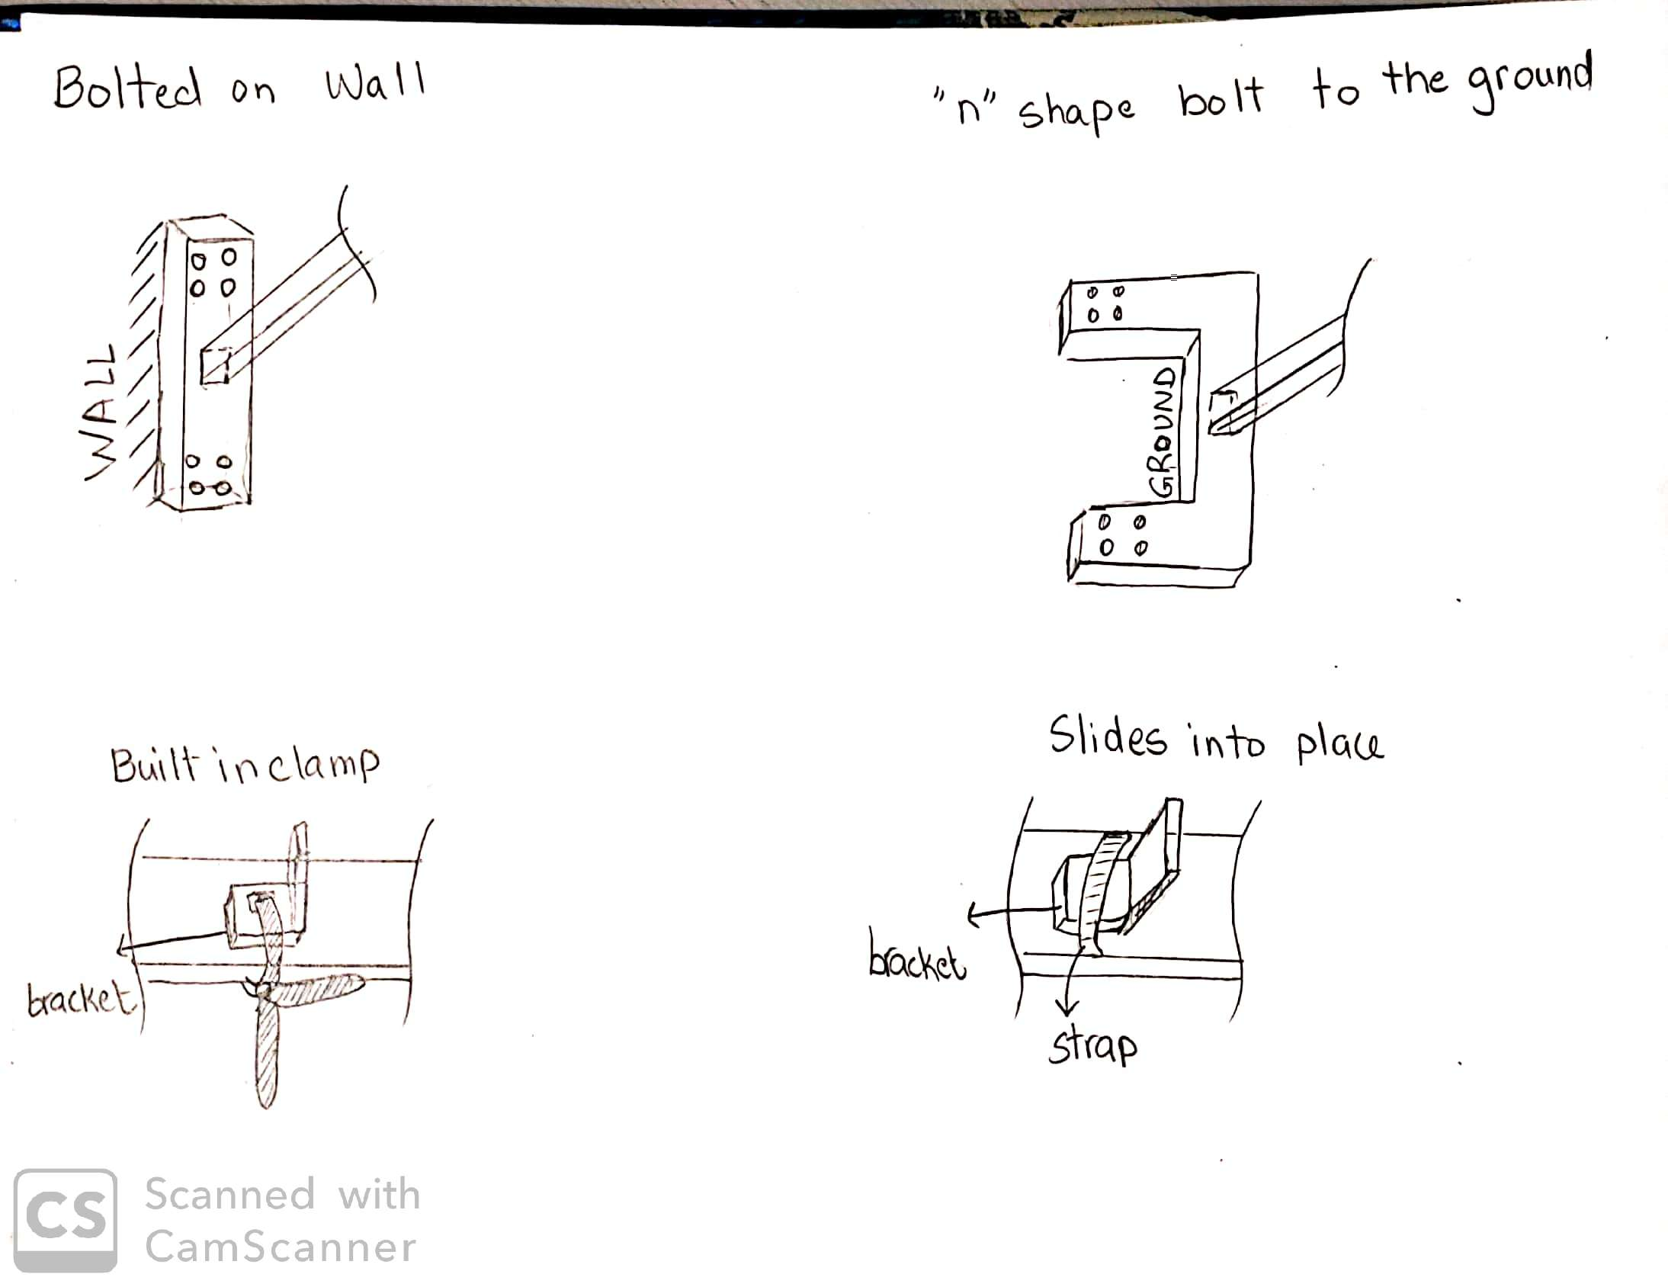

**Figure 23:** Bolted onto the wall

The design in figure 23 has one pro, which is that it occupies less footprint space since it is bolted to the wall. The cons to using this design is that it will constrict the jigs to be placed on walls and it will require a great amount of effort to bolt the jig to the wall.

#### 5.2.5.3 Design #3: “n” Shape Bolted to the Ground

This design entails of an n shaped structure as a solid base from which all other components are supported. The design is to be bolted on the ground from the side farthest from the downward force to balance the jig. This is illustrated in figure 24 below.



**Figure 24:** “n” shaped base bolted to the ground

The pros of this design is that it requires minimal floor space as the downward force is being balanced in two locations where the bolts are placed. This also doesn’t act as an impediment to the user, the base is directly beneath the rear frame support structure where no welder will stand. The cons of this design are that the downward force is acting on the far side of this base, requiring maximum counter force to maintain stability.

### 

### *5.2.6 Subsystem #6: Locking Brass Brackets*

This subsystem locks the brass brackets in place to make sure that they are positioned accurately when they are welded onto the horizontal copper pipes. Since the designs in this subsystem takes care of locking and positioning, they satisfy the position component and secure component from the functional decomposition.

#### 5.2.6.1 Design #1: Indented Surface With Slider

This design will be located on the skeleton of the jig. It is made up of two parts, the first has an indented surface where the bracket goes in and the second has a slider which slides on top of the bracket to lock it into position. The sketch of the design is found in figure 25.



**Figure 25:** Indented surface with slider

The design in figure 25 has two pros. The first pro is that the indented surface makes sure the bracket will have an accurate position when it is welded since it eliminates human errors that could be produced when measuring the distance by hand. The second pro is that it is easy to handle and does not require a large amount of time to place the brackets and secure them. The only con to this design is that the bracket could be stuck in the surface when it is brazed due to heat expansion.

#### 5.2.6.2 Design #2: Built in Clamp

This design consists of a bracket which is constructed with the skeleton frame of the jig. This clamp is a single unit with the jig and cannot separate, minimizing the inconvenience to the welder. This device can be seen in figure 26.



**Figure 26:** Built in clamp

The pros of this device include it minimizing part count by not acting as a separate component. Also with the clamp being built in the bracket which it secures will always be clamped with no possibility of human error of not clamping the bracket during brazing. The cons of this process are that it is not as accurate as say an indented surface as the bracket must still be secured on the horizontal plane. This design also doesn’t ensure proper placement of the bracket as does the indented surface.

#### 5.2.6.3 Design #3: Slides into Place

This design consists of a bracket which is slid into a strap securing the bracket in both the horizontal and vertical directions. This is illustrated below in figure 27.



**Figure 27:** Bracket slide

The pros of this design are the effectiveness of securing the bracket, as this is secured in the horizontal and vertical directions as opposed to the built-in clamp’s single direction. This design is easy to use by the braze welders as it doesn’t require much physical effort such as positioning and tightening a clamp. The cons are the lack of stability. The strap does restrict movement in both the vertical and horizontal directions, although not all horizontal movement as it can still slide out from where it is slid in.

# 6 DESIGN SELECTED – First Semester

This section contains a description of the final design. First, the preliminaries and fundamental components of it are detailed in depth. Design changes are discussed regarding how the design changed since the previous report publication. Why these changes were made are discussed on a qualitative basis. Furthermore, engineering principles are substantiated with some mathematical calculations.

## 6.1 Design Description – First Semester

The final design of the jig as of the first semester utilizes rotation about an axis similar to what SunTrac currently uses. The jig rotates on a 10-degree offset from the vertical plane where the pivot point is supported by a tripod which stands near 72 inches tall with a 5.4 square foot footprint. The jig in it's 8-foot configuration swings to a height of 10.8 feet from the base of the tripod. The operational component of the jig is made from three sets of square telescoping tubes that allow it to change configuration sizes. These tubes have holes for pins where a pin can be removed, adjusted to a new configuration size, and reinserted to lock it in place for another manifold size. Vertical copper pipes are supported by two standoffs which are L- beams with u-shaped holes cut into them. The horizontal pipes are mounted with power screw clamps attached to each end of the jig. There is a gear rigidly mounted to the back of the jig which rotates with it. This gear is coupled with a spring, an interlocking wedge, and a cable which connects it to the foot pedal at the base of the tripod. When the foot pedal is pressed it actuates the wedge out of place allowing the jig to swing freely. Then when the foot pedal is released, this wedge reinserts and the jig gets locked back in place.

### *6.1.1 Design Preliminaries and Changes Made*

The requirements that SunTrac laid out for us were heavily considered in the design. Considerable changes have been made since the preliminary report. Most of the design features were implemented for safety reasons. The jig is offset at a 10-degree angle so it can stand upright before being bolted into the floor. The pull string and gear locking mechanism allows the operator to work more comfortably and safely. Power screws ensure a rigid grasp onto the manifold to prevent it from falling out. Additionally, one leg of the tripod is facing in front instead of two to avoid it being a tripping hazard.

A significant change made is the amount of telescoping tube sets were reduced. Originally there were to be five sets of tubes, but since one row of vertical pipe standoffs are now a single part, there is no need to have as many individual sets of tubes as there are vertical pipes to accompany each standoff. Each individual standoff becoming a solid piece greatly increases rigidity. Additionally, less tube sets indicates fewer locking pins, so there is a shorter time to reconfigure the jig for another manifold size. So not only does this design change functionally work but also reduces raw material and manufacturing costs.

The gear used for the locking mechanism was increased from a 2-inch diameter to a 4-inch diameter. Initial calculations showed that the smaller gear would yield with a 108.7 lbf load at the end of the jig. This force could be easily achieved with a simple accident like a cart collision. Thus, the gear size was increased to make it stronger.

### *6.1.2 Engineering Calculations*

Some engineering calculations were conducted to substantiate some of the design changes. With less telescoping tubes, the jig becomes easier to maneuver, but there is a potential for it to deflect more since there isn't as much reinforcing material. How much weight is removed and how much axial stress the new design may endure is conducted in two analyses. Then, a new force that the larger gear can withstand is calculated.

#### 6.1.2.1 Reduced Weight Analysis

This analysis is to examine how the reduced amount of collapsible tubes will affect the weight of the jig. For this, first the dimensions of one set of telescoping tubes will be considered. The density of carbon steel is 0.284 lb/in^3. The weights of each tube are as follows.

**Large Tube**

𝑉 = 𝐿(𝐴 − 𝐴) = 48 𝑖𝑛 ((2.5 𝑖𝑛 ∗ 2.5 𝑖𝑛) − (2.29 𝑖𝑛 ∗ 2.29 𝑖𝑛)) = 48.28 𝑖𝑛 𝑊 = 𝑉 ∗ ⍴ = 48.28 𝑖𝑛 ∗ 0.284 𝑙𝑏/𝑖𝑛 = 13.71 𝑙𝑏

**Medium Tube**

𝑉 = 𝐿(𝐴 − 𝐴) = 12 𝑖𝑛 ((2.25 𝑖𝑛 ∗ 2.25 𝑖𝑛) − (2.04 𝑖𝑛 ∗ 2.04 𝑖𝑛)) = 10.81 𝑖𝑛 𝑊 = 𝑉 ∗ ⍴ = 10.81 𝑖𝑛 ∗ 0.284 𝑙𝑏/𝑖𝑛 = 3.07 𝑙𝑏

**Small Tube**

𝑉 = 𝐿(𝐴 − 𝐴) = 12 𝑖𝑛 ((2.0 𝑖𝑛 ∗ 2.0 𝑖𝑛) − (1.79 𝑖𝑛 ∗ 1.79 𝑖𝑛)) = 9.55 𝑖𝑛 𝑊 = 𝑉 ∗ ⍴ = 9.55 𝑖𝑛 ∗ 0.284 𝑙𝑏/𝑖𝑛 = 2.71 𝑙𝑏

**Total Weight Reduced**

There is 1 large tube, 2 medium and small tubes per set, so the weight of each set is.

𝑊 = 𝑊 + 2 ∗ 𝑊 + 2 ∗ 𝑊 = 13.71 𝑙𝑏 + 2 ∗ 3.07 𝑙𝑏 + 2 ∗ 2.71 𝑙𝑏 = 25.28 𝑙𝑏 𝑝𝑒𝑟 𝑠𝑒𝑡

Thus, with two removed sets, there is a 50.58 lb. weight reduction.

#### 6.1.2.2 Thermal Expansion Maximum Axial Stress

When the copper tubes are heated up thermal expansion will occur in both the axial and radial directions. Depending on what the pipes are coincident with, this may induce very high stresses on the pipes and/or the pipe surroundings [Mech Mat]. How much stress is induced in the jig frame can be found from this. Thermal expansion in the axial is calculated to provide some insight on this phenomenon.

**Axial Deflection**

𝛅axial = 𝛥𝑇(𝛼)(𝐿) = 1375𝐹(9.4 ∗ 10𝑖𝑛/𝑖𝑛 ∗ 𝐹)(8𝑓𝑡 ∗ 12𝑖𝑛/𝑓𝑡) = 1.24 𝑖𝑛

There are assumptions built into this computation. This assumes that the pipe uniformly heats up to the maximum temperature during brazing; but this is not highly unrealistic given copper has excellent thermal conductivity. It also assumes that the expansion is unrestricted. The axial force can be found as such.

**Axial Stress**

𝐹 = 𝐸 ∗ ⍺ ∗ 𝛥𝑇 ∗ 𝐴 = (17 ∗ 10𝑝𝑠𝑖) ∗ (9.4 ∗ 10𝑖𝑛/𝑖𝑛 ∗ 𝐹) ∗ 1375𝐹 ∗ (0.1104in^2) = 24,257 lbf

The copper pipes are brazed one at a time, and there are three sets to restrain this thermal expansion, each with a minimal cross- sectional area of

**Cross- Sectional Area**

𝐴 = ((2.0 𝑖𝑛 ∗ 2.0 𝑖𝑛) − (1.79 𝑖𝑛 ∗ 1.79 𝑖𝑛)) = 0.796𝑖𝑛 ∗ 3 𝑠𝑒𝑡𝑠 = 2.39 𝑖𝑛

**Induced Axial Stress**

𝜎 = 𝐹/𝐴 = 24,257 𝑙𝑏𝑓 / 2.39 𝑖𝑛2 = 10,150 𝑝𝑠𝑖

Some considerations to this calculation. It assumes that the thermal expansion is uniform which gives the largest expansion, and that the steel remains rigid, which induces the highest stresses. So with this conservative modeling, a factor of safety of 7 is maintained, which indicates the design is robust and will last.

#### 6.1.2.3 Gear Force Analysis

How much force would it take to break the gear if a force was applied at the bottom of the jig? The manufactured gear selected is 4.0 inches in pitch diameter, has 48 triangular teeth, is 0.88 inches wide, is a spur gear with a 20-degree pressure angle, and is made of 1020 carbon steel. These next set of equations came from Shigley's Mechanical Engineering Design [17] to evaluate the spur gear.

**Spur Gear**

𝑃 = 𝑇𝑃𝐼 (𝑇ℎ𝑟𝑒𝑎𝑑𝑠 𝑃𝑒𝑟 𝐼𝑛𝑐ℎ)

𝑛 = 𝑛𝑢𝑚𝑏𝑒𝑟 𝑜𝑓 𝑡𝑒𝑒𝑡ℎ

𝑡 = ℎ𝑎𝑙𝑓 𝑡𝑜𝑜𝑡ℎ 𝑡ℎ𝑖𝑐𝑘𝑛𝑒𝑠𝑠

𝑃 = 𝑛/𝑑 = 48𝑡𝑒𝑒𝑡ℎ/4𝑖𝑛 = 12 𝑇𝑃𝐼

𝑡 = 𝜋/(2 ∗ 𝑃) = 𝜋/(2 ∗ 12𝑇𝑃𝐼) = 0.1309 𝑖𝑛

𝐴c = 𝑡 ∗ 𝑤 = 0.1309 𝑖𝑛 ∗ 0.88 𝑖𝑛 = 0.115 𝑖𝑛

This portion of the analysis was to determine the cross-sectional area of the tooth. For the rest of the analysis, halfway up the triangular tooth is called the pitch diameter, the distance between the tooth tip and the root. The cross-sectional area of this part of the gear tooth may be used in transmitted force modeling for it is commonly a contact point at a 20-degree pressure angle gear. Next, the moment net sum about the pivot point is found to solve for the reaction force that the gear needs to give in order to maintain equilibrium, and this reaction force is found by dividing the yield strength of stainless steel (72,800 psi) [16] by the cross-sectional area of the half tooth thickness multiplied by the cos of the tooth angle.

∑𝑀 = 0 = 𝐹 ∗ 𝐿 − 𝐹 ∗ 𝑅 ==> 𝐹 ∗ 𝐿 − 𝐴𝜎 ∗ 𝑐𝑜𝑠(20) ∗ 𝑅

0 = 𝐹 ∗ 48 𝑖𝑛 − 0.115 𝑖𝑛 (72,800 𝑃𝑠𝑖) ∗ 𝑐𝑜𝑠(20) ∗ 2 𝑖𝑛

𝑆𝑜𝑙𝑣𝑖𝑛𝑔 𝑓𝑜𝑟 𝐹 𝑔𝑖𝑣𝑒𝑠 𝐹 = 327.8 𝑙𝑏𝑓

So this shows that when the jig is in its eight foot long manifold configuration then if one were to apply 327.8 pounds of force then they would yield the gear. This larger gear size shows near 3 times the strength than the smaller gear.

### *6.1.3 First Prototype*

A 1/4 scale model prototype was constructed to not only demonstrate the design concept but to also allow the team to evaluate flaws and potential changes. The Prototype doesn't utilize all of the mechanical components that are detailed for the final design. for example, does not have working power screws, the foot pedal gear stop, or the locking pins. Given the resources available, these components would have been difficult to not only make, but also to have been functional.

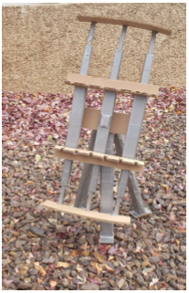

**Figure 28:** 1/4th Scale Prototype of Complete Jig

It was during the construction of the prototype when the team got the idea to reduce the amount of tube sets from five to three. The two other sets seemed intuitively unnecessary. It was determined that at least three are needed so one could be the center and attached to the bearing, while the other two are for guidance and rigidity. The other idea found during construction was to make the one tripod leg in front instead of two. One leg placed directly under the jig would be less of a tripping hazard than two extending along the sides of it. This also allows attaching the foot pedal to this one leg and have the cable it's coupled with be directed by the leg instead of it being in the open. This prototype also helped the team visualize that a subsystem would be required to actuate the vertical working height of the jig. This understanding led to a design change to the final design to add a system to change the vertical working height.

## 6.2 Implementation Plan – First Semester

This section details the team's current plan in order to implement the design. This includes putting the design into effect through constructing an operational scale prototype, needed resources to accomplish this goal, and a schedule to abide by. Given in the project description, one of the final deliverables is to deliver a 1/4th scale model to SunTrac. The team anticipates this being the first step of implementation. The plan is to fabricate it entirely out of aluminum, have each dimension completely to scale, and be able to demonstrate each dynamic and mechanical feature. Since it will be made of aluminum, it won't be able to withstand the excessive temperature from braze welding a copper manifold. However, this wasn't designated to be a requirement, as constructing a miniature scale copper manifold proves no use to SunTrac.

### *6.2.1 Needed Resources*

The bill of materials in Appendix B details all of the raw materials and their costs that need to be purchased for the full-scale jig assembly. The final CAD package and drawings detail which piece from the bill of materials corresponds to each component. For the 1/4th scale prototype, Suntrac’s partnered machine shop shall be in charge of fabricating each component. Initially the team will request quotes to determine how expensive the scale model components will cost. The components will be requested through SunTrac because SunTrac receives regular customer discounts from this machine shop. The individual pieces will be shipped to the team for assembly. SunTrac will cover the expenses of fabrication and shipping. Should modifications be required due to some unprecedented error, they will be made at our own expense with our own resources and the NAU machine shop. Then, alterations to the CAD package will be made accordingly.

A similar process shall be conducted with the full-scale final product. SunTrac will submit the team’s detailed drawings to the machine shop and receive quotes. The team will thoroughly revise the drawings looking for possibilities and/or following recommendations to utilize DFMA guidelines to reduce costs and increase manufacturability. With the final submission of the drawings, the machine shop will fabricate these parts and send them to the SunTrac facility in Tempe to store them. The team will make a trip down to SunTrac to assemble the jig.

### *6.2.2 Implementation Schedule*

The second half of the Gantt chart details the team's current plan for the second semester of Capstone. This chart includes Capstone specific submission dates for assignments and when they are to begin. Per the team charter, each team assignment is intended to be finished 24 hours before the submission time. The chart can be seen in figure 4

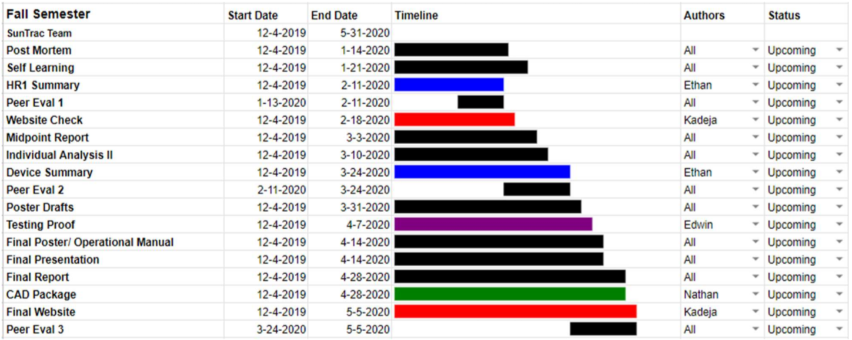

**Figure 29:** Current Plan For Implementation

The plan structure for the next semester is a bit rudimentary. Many of the Capstone assignments have yet to have further details explained and submission dates designated. Nonetheless, the current work structure of this portion is intended to span from December 4th 2019 to May 5th, 2020. Contacts/ meetings with SunTrac, trips made to the facility, requesting machine shop quotes, reviews, fabrication time, and prototype assembly are not detailed in the chart. The team's current plan follows as such in table two.

**Table 2:** Rough Dates for SunTrac and Machine Shop Proceedings

|  |  |
| --- | --- |
| Activity | Anticipated Date |
| Submit Prototype Drawings and Package | December 16, 2019 |
| Review Machine Shop Prototype Quotes | January 4, 2020 |
| Intended Resubmission of Prototype Package | January 13, 2020 |
| Prototype Fabrication/ Assembly | January 13, 2020 - January 31,2020 |
| SunTrac Trips | January 11, 2020, 5th, and 10th Week of Semester |
| Final CAD Drawings and Package Submission | February 10, 2020 |
| Review Machine Shop Quotes | February 17, 2020 |
| Intended Resubmission of CAD Package | March 1st, 2020 |

The first submission of prototype parts occurs at the end of first semester. This is because of the Capstone final CAD package assignment. Since the CAD package will be done to completion by then with all the associated drawings, the team wanted to send those in before winter break started so then a portion of winter break could be used as waiting time for receiving feedback from the machine shop. Should the CAD package need revisions those will be done over winter break and resubmitted. Before the second semester begins, we intend to convene in Phoenix and meet with SunTrac before returning to Flagstaff. This meeting should be to address the current state of our design, to receive input, and to possibly use that time for assembly should the machine shop deliver the components ahead of the schedule. Other meetings with SunTrac are scheduled for later in the semester. The team anticipates submitting the final CAD package around the Monday of February 10th.

### *6.2.3 CAD Model Views*

This section contains figures and explanations on the current state of the jig design. The individual parts and 3D assembly were constructed in SolidWorks. Future revisions are intended to take place as well as the addition of a few components. This is contingent on SunTrac’s opinion of the design. The exploded view of the assembly can be seen in figure 30.

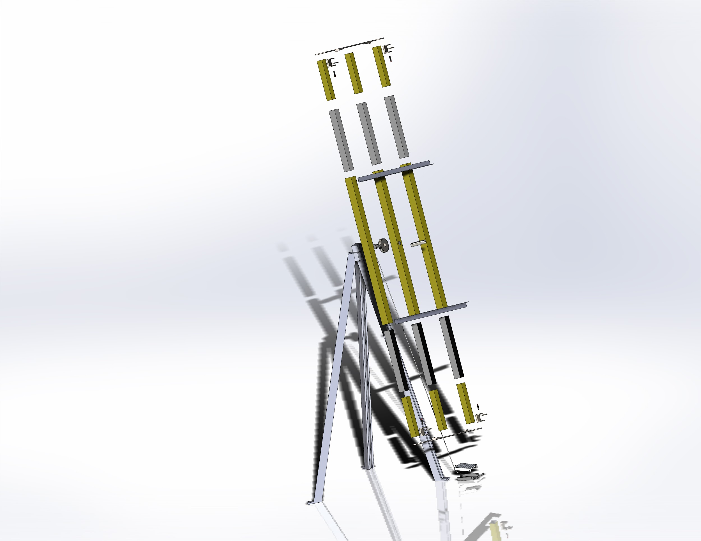

**Figure 30:** CAD of the Most Finalized State of the Design

There are 40 components in total here. The tripod has holes in each of the feet so it can be bolted to the floor. The top of the tripod contains a housing which fits the bearing to support the shaft and the gear. The gear has an interlocking wedge that is held up with a small arm and spring. This arm is attached to the cable which is attached to the foot pedal. The gear is fused to the center large telescoping tube and the shaft so that it is only free to rotate on the bearing. The L- beam standoffs are welded at each end to the large telescoping tubes. The small telescoping tubes are welded to the end plate, which are welded to the power screws and their housings. The assembly can be seen in figure 31.

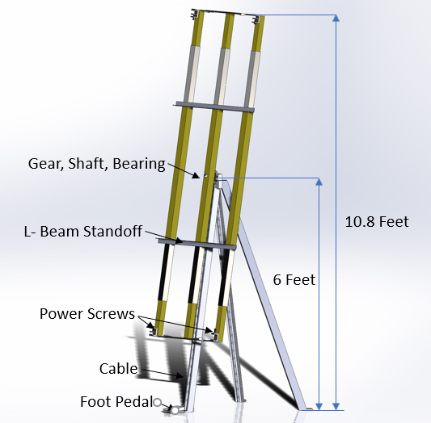

**Figure 31:** Jig CAD Assembly with Annotations

The tripod stands 72 inches (6 feet) tall by itself and the gear positioned behind the middle set of telescoping tubes is 4 inches in diameter and 0.88 inches thick. The largest tubes measure 2.5 in x 2.5 in x 48 in and are spaced 14 inches apart from each surface. The medium tubes are 2.25 in x 2.25 in x 12 in and the smallest tubes are 2.0 in x 2.0 in x 12 in. The u- standoffs are 40 inches wide, made from the 1.5 in x 1.5 in L beams. The centers from each of the u- cutouts are 7.625 inches apart per the dimensions SunTrac uses.

# 7 IMPLEMENTATION – Second Semester

Over the previous several weeks, many of the set benchmarks detailed in implementation memo one have been accomplished. This included purchasing the parts detailed on the bill of materials and having them shipped to the SunTrac facility. Once all the parts were shipped to SunTrac’s manufacturing facility, they were cut to size and assembled as shown in the completed CAD package. 90% of the project is completed with an additional 10% delayed due to implemented regulations by SunTrac to combat the COVID-19 crisis. These updates have been accomplished over three consecutive Fridays and Saturdays from 3/6 to 3/21. During the manufacturing of the jig, multiple changes were made that primarily increased the rigidity and structural integrity of the jig frame. The other subsystems were largely unchanged from the last report.

### 7.1 Manufacturing

Since the design consists solely of steel parts, power tools were a necessity in cutting, drilling, grinding, and welding the jig together. SunTrac’s manufacturing facility had all the needed tools in order to be successful in this project. The first step in the manufacturing process was to measure the parts with a measuring tape and marked with soapstone. Calipers were used for cuts requiring higher precision and then a punch would mark holes for drilling and tapping. Ample use of WD-40 was used dually for lubrication and cooling of the cutting blades and drill bits. Balances and angle gauges were there to measure out and then check our work.

The larger tools include a bandsaw, chop saw, angle grinder, drill, and 110V ARC welder. The bandsaw was used to make precise straight cuts in the steel. A chop saw and a portable band saw aided in making angled cuts; particularly the frame is composed of many angled cuts. Any cuts that were made were filed down with an electric angle grinder or simple file. A drill press was utilized for making accurately placed holes for the telescoping tubes and locking assembly. A handheld drill was more feasible for making holes in the frame as some were angled. The welding was the only portion that the team did not do as that was left to a SunTrac employee and their personal arc welder.

All calculations were conducted by using the detailed CAD package to measure segments virtually and making adjustments to our physical parts. This method ensured that the angles were cut accurately and complex parts would fit with the rest of the assembly. All other testing procedures require the jig to be completed and therefore must be postponed till business at SunTrac returns to normal. A detailed list of other testing procedures have already been written given to the SunTrac executive board.

### 7.2 Design Changes

Few changes occurred between implementation and the final product. The main change is that the foot pedal locking mechanism assembly was changed out for a pull string locking mechanism assembly. This change was made because it required less parts and functioned smoother with the variable working height frame. The pull string assembly functioned by pulling a string to disengage mechanical interference at the rotating gear which allowed for rotation. When not pulled, a spring would force a piece of stationary metal into the gear restricting motion. Other less notable changes include switching out desire’s screws and bolts for more available screws when shopping at ACE hardware.

# 8 RISK ANALYSIS AND MITIGATION

To analyze failure and risk, a Failure Modes and Effects Analysis (FMEA) was performed over the subsystem mechanisms in the design. The FMEA is an analysis of the components which four critical subsystems consist of, where the failure modes for each part have been isolated individually. The subsystems analyzed in this process include the pivot mechanism about which the jig face rotates, the pull handle, and the locking mechanism which the pull handle is attached to, as well as the sliding tubes which satisfy the variability engineering requirement. To quantify the effects of the failures of each subsystem component, a risk priority number is calculated in which three values are generated all on a 1-10 scale. These values being Severity (S) based on how severe the failure is, Occurrence(O) based on how likely this failure is to occur in its application, and Detection (D) being how easily the defect will be detected.

## 8.1 Potential Failures Identified Fall Semester

A shortened version of the FMEA has been conducted to illustrate in the report the top ten most considerable risks, that is the ten risks with the greatest risk priority number; this can be seen below in Table three which lists potential failures for each component, the causes and effects of these failures, develop design control tests to detect failure before production, and provide recommended action.

**Table 3:** Shortened FMEA

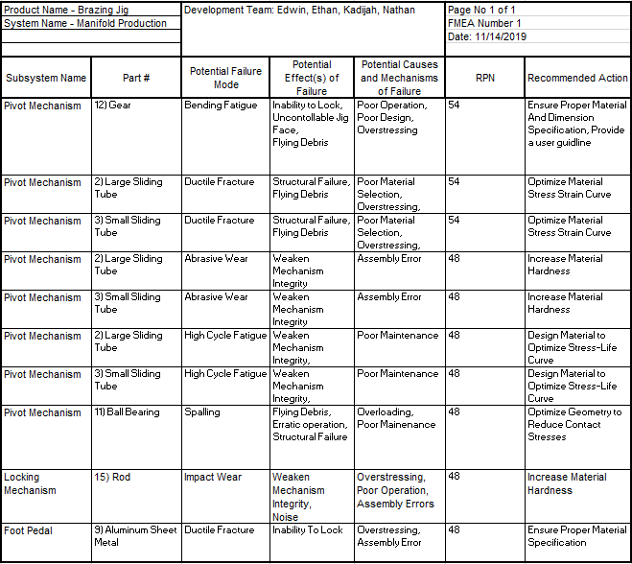

This shortened FMEA disregards a few critical elements of the full FMEA process which can be seen in appendix C. These top ten failure modes are broken down and analyzed in terms of cause, effect, and recommended action in the sections below.

### *8.1.1 Potential Critical Failure 1: Gear Tooth Bending Fatigue (RPN 54)*

To actuate the locking of the jig face, a rod is mechanically positioned between the teeth of a gear as a part of the pivoting subsystem. The repeated impact between these two components if not performed properly will subject an excessive bending stress onto the gear’s teeth. Once these stresses exceed the local fatigue strength, a local fatigue crack propagates at the tooth base. The effect of this failure is a loss of the locking mechanism functionality, and perhaps flying gear tooth debris. This failure will be mitigated through performing gear tooth analysis to ensure proper material specification, these specs will be outlined in the performance instructions

### *8.1.2 Potential Critical Failure 2: Large Steel Tube Ductile Fracture (RPN 54)*

When minimizing cost, a soft metal may be considered for the sliding tubes on the jig face. This is considered in terms of failure as ductile fracture. If this material is repeatedly loaded in the plastic deformation region, ductile fracture can be experienced. This failure will cause complete structural failure, and perhaps flying metal debris. For this reason, this failure mode is rated a 9 on the 1-10 severity scale, and consequently is tied for the most significant failure mode. To minimize the chance of this happening, a comprehensive dynamic load analysis will be conducted to ensure that the yield strength of the material won't be exceeded during the life time of the jig.

### *8.1.3 Potential Critical Failure 3: Small Steel Tube Ductile Fracture (RPN 54)*

This failure mode is remarkably similar to failure mode 2. There are two sliding tube elements on the jig face to allow for a full 4-foot extension. The failure mode of the smaller tube has all of the same causes and effects of the larger tube. Although, for mitigating action the dimensions and forces of the dynamic loading analysis will be different, resulting in a different risk of failure.

### *8.1.4 Potential Critical Failure 4: Large Tube Abrasive Wear (RPN 48)*

For the variability engineering requirement to be satisfied, the variable sliding tubes hold great weighting in their complete and accurate use. A failure consideration is the wear of these tubes when repeatedly sliding causing physical abrasion between them. After numerous operations and sliding iterations these tubes will wear and scrape off particles, causing a small margin of tolerances stack up as the accurate fitting of these tubes are mandatory. This will also create a safety hazard as particulates will be breathed in by workers. This failure will be mitigated by conducting research on a cost effective and situationally accurate lubricating material that is fire resistant and abide by engineering requirement restrictions.

### *8.1.5 Potential Critical Failure 5: Small Tube Abrasive Wear (RPN 48)*

This failure mode is comparable to that of the large sliding steel tube abrasive wear more-so than other failures that are shared between the sliding tubes. As ideally, the material analysis regarding project restrictions will determine a lubricant which can be applied across both materials. Although this mitigating action may be contingent on another as if the analysis which will determine the sliding tube material results in separate materials, a lubricant will be chosen specific to each. Other than this variation, the other factors of this failure such as cause and effect are the same for each.

### *8.1.6 Potential Critical Failure 6: Large Steel Tube High Cycle Fatigue (RPN 48)*

A considerable failure mode for the large sliding steel tube is the fatigue due to small elastic strains under a high amount of loading cycles. The sliding steel tubes will undergo many cyclic loadings as the jig face configuration varies from 4’ to 6’ to 8’. it will also experience this repeated loading as the jig face is rotated about an axis and the load is applied to the structural support under different conditions. The effects of this occurrence is eventual, yet noticeable, failure as the material slowly reaches its fatigue limit. This can cause complete loss of primary function, as well as potential flying debris, thus the severity is high, although its ability to be detected and occurrence counteract the severity. A material analysis will be conducted to determine a material that can withstand the weight of the jig face and 8’ copper manifold under different configurations.

### *8.1.7 Potential Critical Failure 7: Small Steel Tube High Cycle Fatigue (RPN 48)*

The dynamic loading of the various copper manifolds in different orientations affects both the large and small sliding tubes. Perhaps one more than the other, although this will be determined in a dynamic loading analysis. The causes and effects of the larger sliding tube carry over to the smaller, although the smaller is less severe by a small margin as this failure contains less mass to be potential flying debris. A material analysis will be conducted that is similar to that of the larger tubes, although different dimension and load applications will be considered.

### *8.1.8 Potential Critical Failure 8: Ball Bearing Spalling (RPN 48)*

The pivot mechanism is a critical subsystem of the brazing jig as it allows the primary function to be carried out, If the Jig face couldn’t rotate, the top of the copper manifold wouldn’t be reachable. Although this contains much risk, as this is the second critical failure exclusive to the ball bearing. The bearing is susceptible to three types of spalling: Geometric Stress Concentration (GSC), Point Surface Origin (PSO), and Inclusion Origin Spalling. Inclusion Origin Spalling is negligible in this case as this failure mode requires millions of cycles. This application focuses on the intensity of few cycle amounts. The other two failure modes are triggered through localized stress regions, which is a heavy consideration for the pivot mechanism application as the ball bearing will be inclined in a tilted plane, causing a localized stress region from the heavy jig face weight near the back of the bearing inner diameter. An analysis on this loading setup will be conducted to better inform the team members of this potential failure mode, and to ensure that proper bearing material specification and size is concluded.

### *8.1.9 Potential Critical Failure 9: Rod Impact Wear (RPN 48)*

The locking mechanisms interacting dynamic components involve great reactionary forces. Just as this force exchange between rod and gear can result in bending fatigue on the teeth of the gear, this can result in impact wear on the rod. The severity of this failure mode is not as high as bending fatigue as there will be notice of failure before severity reaches great proportions. For example, the rough contact interface will create minor erratic locking operation as well as distinct noise. To mitigate this failure a material analysis and dimension analysis will be carried out in which proper hardness will be found in which this issue will not arise during the lifetime of the jig or maintenance periods.

### *8.1.10 Potential Critical Failure 10: Pull Handle Tensile Yield (RPN 48)*

The pull handle is a flexible steel cable that dangles down from the locking mechanism. It attaches to a pin and when pulled on it removes the pin which meshes with the gear in the locking mechanism assembly. With this pin removed, the jig face is able to rotate freely. This component will be used multiple times in operation and it is important to consider the effects of repeated use. The current system used by SunTrac USA is a free rotation controlled by the hand, so this concept is not unfamiliar and consequently doesn’t entail complete severity. To reduce this failure risk, a dynamic loading analysis will be carried out to determine the average operating specs. A material will be tailored to these specs and an operating guideline will be constructed.

## 8.2 Risk and Trade Off Analysis

To analyze critical risks and how they relate to each other, the design team took a quantitative approach. Scenarios were devised which beneficially impact respective engineering requirements. These scenarios were then analyzed regarding how they influence engineering requirements as well as risk. To do this, the effect(s) of each scenario on its respective engineering requirement were stated, then each effect was assigned an engineering requirement which it impacts positively (+) or negatively (-). The weighting of impact was determined by the criterion weighting of the decision matrix. If an effect has a positive influence on the engineering requirement, it was assigned a positive value equal to the decision matrix weight for that particular criteria, if the influence is negative this same value would become negative. Two other factors to accurately weigh the impact of these scenarios are the weight of the engineering requirement which the actions are positively affecting, as well as the risk factor. The risk factor is determined through listing all of the potential risks of the action. For example, when considering reducing the jig face structural member count from six to three, this entails increased susceptibility to yielding, high cycle fatigue, and abrasive wear as the forces of operation are concentrated across less area. The severity, detection, and occurrence ratings were considered in creating a risk priority number for each of these scenarios, then this number was divided by ten to create a zero to one relative weighing scale to match the rest of the analysis. The risk factor, engineering requirement weight, and summation of effect impacts were combined in creating a total rating. The total ratings of all of the engineering requirements benefiting actions were taken to solve for a relative rating. An excerpt of this process is outlined in table four below.

**Table 4:** Shortened Risk Trade Off Analysis

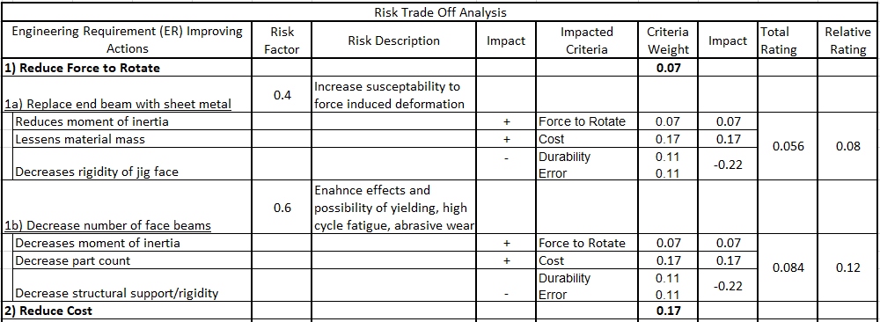

The table above illustrates this process for a single engineering requirement with two benefitting actions, the entire process is outlined in appendix D. The conclusions which can be drawn from this process are listed in table five below.

**Table 5:** Risk Analysis Results

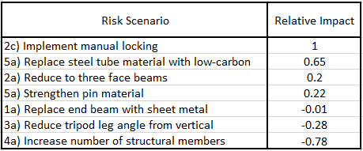

Given the way that these relations were solved for result in a nonobjective scaling of influence regarding engineering requirements and risk. An action with a rating of 1 is the best action which can be currently taken to benefit engineering requirements with regard to its impact on other engineering requirements while also considering risk. If the value is positive there is a net positive impact regarding engineering requirements and risk, if the value is negative the action is detrimental in regard to these considerations. So, it can be concluded from this analysis that implementing manual locking is the most beneficial action to currently take. This is significant as if this is carried out, the design will revert back to the original design currently used in SunTrac USA’s brazing process, and a new method to satisfy the adaptability sub-function will be required. Although this result is quantitatively justified, this action may not be taken as the current theoretical mechanically actuated locking system may be worth the negative cost influence. This concern will be brought to the project client Stu Siebens and he will have the final decision on whether or not this action will be carried out.

## 8.2 Risk Mitigation

The component with the greatest risk priority number is tied among the steel tubes. This is because the steel tubes are the most essential and multi-faceted component which holds the greatest tolerances, operate dynamically, and contain a lot of potential energy. These telescoping tubes are in and of itself the bulk of the entire prototype, and if they fail, the prototype fails. Although due to this reason the team has spent due time mitigating these risks. More than one entire manufacturing day was spent solely drilling the pin locations on the telescoping tubes to ensure that the spacing is of correct tolerance, this was achieved. The angle irons, which restrict movement from the vertical tubes during operation, while providing continual structural support to the telescoping tubes have been repositioned more towards the center of the tubes to mitigate effects of buckling. The guide rail is the next riskiest part with an RPN of 32. The heightened risk level for the guide rail differs slightly from the telescoping tubes in that there aren’t any risks associated with the guide rails potential energy, or the tolerancing associated with it, all of its risks revolve around its structural integrity. The resilience of this component is so important that an FEA analysis has been done on it. It was determined that the guide rail would surely experience risk during operation. Once the prototype became developed enough, this was physically tested and confirmed to be a serious issue. Extra 2x2 carbon steel had been laying around from a telescoping tube cut, this was then welded behind the guide rail and bolts then secured the guide rail to this new support beam, this is illustrated in [Fig. 2]. After this risk mitigated took place, deflection of the guide rail was then tested again and shown to withstand the greatest loads that it would experience during operation. Another critical part regarding risk is the pulley eyebolt. This eye bolt holds the pulley upright, which holds the locking mechanism, which in turn holds the weight of the entire jig face. If this component fails, it would risk serious injury to anyone nearby. To mitigate this risk two nuts were placed on top of two washers to account for extra stresses that may occur. This is the only action that took place for this risk as the eyebolt specifications met and surpassed the conditions it would experience during operation.

There isn’t much risk tradeoff for this project as the bulk of solutions to mitigating risk is to add structural supports where necessary. Each time structural supports have been added, they’ve had no negative effect on other components, and sometimes even positive effects. Such as in the case of repositioning the telescoping tube angle irons to minimize bending at the jig faces most susceptible location also happened to reinforce the vertical copper manifold tubes where they were more susceptible to deflection. Rather than worrying about trading risk, the focus for this project is to not over-engineer the structure in an effort to save on costs.

# 9 TESTING

Most of the testing that the team originally planned to perform was not completed due to the virus outbreak. The final product was not completely manufactured since SunTrac suspended all visits until the outbreak had subsided. Out of the five different testing procedures that were set, only two were completed and satisfied. The first testing procedure that was satisfied is of the BOM breakdown. The final version of the BOM had a total cost under $1600 and about 90% of the parts were standardized parts bought from Mccmaster Carr. This testing procedure satisfied the engineering requirements of the cost and the standardized parts. The second testing procedure that was satisfied is the measurement of the jig frame to make sure the base of the jig takes up less than 5ft x 5ft area. This was performed by measuring the triangular base and it satisfied the engineering requirement of footprint. The other three tests require the completion of the device. SunTrac has invited the team to finish the manufacturing process during the Summer of 2020 if the virus outbreak is no more a threat. During that time, the team can complete the testing procedures that were not completed. The team can utilize the Oxy-propane torch in SunTrac’s facility to test the durability and melting temperature of the material. The team can also use a force gauge to measure the force to rotate the jig to see if its reasonable.

# 10 FUTURE WORK

In the future, the team needs to complete the final welds to combine the sub-assemblies of the device. The global virus outbreak did not allow the team to finalize the weldments since SunTrac suspended all visits until further notice. Once the device is welded together and made complete, the final tests need to be performed on the device. SunTrac has invited the team back to finish tests over the Summer of 2020 once the outbreak has subsided. Any updates and changes will be documented in the team’s website. Furthermore, the client will be provided with an operation and assembly manual that will detail the manufacturing and assembly process for future reference. Should SunTrac feel the need to improve the design, the manual will help them know where the alterations can take place. This capstone experience has been beneficial as the team had the opportunity of working with a client in an industry. The team also had the opportunity to work in SunTrac’s machine shop. This experience helped the team bond with the client and acquire a sense of professionalism. If future teams and clients gain the same experience, it will improve the capstone experience and help the team be ready to set out in the industry.

# 11 CONCLUSIONS

The SunTrac team was tasked with building a braze welding jig that is compatible with all three product variations. With regards to this task, this report entails an analysis of the (Fall 2019 - Spring 2020) Mechanical Engineering Design course for the SunTrac Design Team. The analysis will cover topics such as the groups collaborative effectiveness, cohesiveness, and general performance with respect to previously established guidelines and regulations. These topics will be discussed through considering technical questions organized in the categories of Contributors to Project Success and Opportunities/Areas for Improvement. The goal of this report is for the SunTrac Design Team to critically assess and reflect on their Capstone project and provide important feedback for future capstone teams.

## 11.1 Contributors to Project Success

There were many aspects that contributed to the team’s success during the past year. The first aspect was the completion of the purpose and goals that were laid out when the team was created. The team’s main purpose was to create a brazing jig that could hold three different sizes of SunTrac’s standard copper manifold. This was successfully achieved in the past by conducting analysis and direct contact with SunTrac to get their feedback. The team also visited SunTrac multiple times during the past year to understand the customer requirements and manufacture the device. Moreover, most of the goals that were set by the team were accomplished. Each team member gave their utmost effort and worked collaboratively to produce a product of high quality. The ultimate goal was to achieve a grade of 90% or higher on our project through hard work and dedication which was attained.

Another aspect that contributed to the team’s success is the fact that each team member made an effort to follow the ground rules that were listed in the Team Charter [9]. The team made sure there were weekly meetings set up to work on assignments and when that was not possible, the team communicated thoroughly through text to make sure the whole team is updated and on the same page. During the global outbreak, the team made use of video calls to keep updated and produce high quality work. If there was a set meeting and a member of the team predicted that he/she might be late, the team was informed beforehand. In the ground rules, there was a 24 hour reply policy that required the team to communicate regularly which was followed as all team members replied within that time frame. Moreover, the team looked for individual weaknesses within the group, and when they were found, the team helped that individual get back on track, thus ensuring the work that was submitted was of high quality. The team shared a positive work dynamic where team members were encouraged to give ideas and individual efforts were always praised and acknowledged. This dynamic helped the team cope well and no problems were faced.

The effective collaboration demonstrated by the team is a result of abiding by the established regulations, as well as aspects of project performance being used successfully. The most positive aspects of this cohesive performance include willingness, reliability, and relationship. Other aspects of project performance had contributed to success, although won’t be considered here. The team's willingness is proven in a relatively hasty scheduling of a three-hour car trip to visit the client. The team also dedicated three consecutive weekends to visit SunTrac to work on the manufacturing of the device. Noting the importance of willingness some members went out of their way to the point of rescheduling work to ensure participating in the company presentation. This ties into the interconnected reliability of the members as not once has a member of the team fell short of their expressed goals. This reliability allows each to complete their own work with no stress or unnecessary worry of another aspect of the work material to fall short. Lastly, throughout the span of many months of working together the team has developed a relationship of honesty and trust. This relationship allows for a prosperous work environment free from hostility, leaving room mainly for productivity.

Effective tools and practices were initially established but were further developed by the team as the year went on. The team charter became a useful tool for keeping the team informed and on track. A lot of the decision making, concept generation, and evaluation process went well as many of the methods used in the previous x86 classes were utilized. This may also have gone well since the team’s end goal was not only clearly defined, but also guided by example from the Jig solution that SunTrac had already employed. With this came a lot of inspiration for the project and many feasible design choices were generated. One effective practice the team would do is convene a couple of weeks before a report would be due to discuss it and partition the work.

The technical lessons that were learned by the team can be split into the lessons that were learned through success and the lessons that were learned through oversight. The first successful technical lesson that was learned by the team was how to communicate with the executive board of a legitimate company. Communication with SunTrac proved to be different than communicating with teachers or managers from previous jobs because the teams SunTrac contacts are the heads of the company. The team was successful in their communication as SunTrac made a point to commend our team for the professional manner of our phone calls and emails. Another technical lesson learned through success is how to create and maintain an engaging and informative team website using Dreamweaver. The team was successful in this endeavor as website checks were completed ahead of schedule and the extra time was used to help other teams in our class. Since all team members had no previous experience in using Dreamweaver, creating a website also taught the lesson of how hard work can pay off and result in a newly acquired skill.

## 11.2 Opportunities/areas for improvement

When working with a team there are always areas for improvement. An adjustment that would have benefited the team and created further customer satisfaction is by visiting SunTrac before the first semester ended. This would have helped the team because there were some minor adjustments that SunTrac asked for in the design of the jig that could have been accounted for before creating the CAD package. Some of these adjustments included the design of the base of the jig, the height of the jig when brazing a 4-foot manifold, and the location of the rotating mechanism. Furthermore, the team would have profited from sending SunTrac the assignments that were completed in the past since they were not updated regularly on the website. Also, more trips could have been dedicated to manufacturing during the week as that may have resulted in the completion of the final product.

A major adjustment that the team needs to work on is to be time-efficient. One of the ground rules in the Team Charter is that the assignments need to be completed two days prior to the deadline [9]. This rule was taken lightly and due to the team’s busy schedules some assignments were not completed until the day they were due. This deficiency created a problem with the Preliminary Report as it was submitted one minute before the deadline. As a result, the team did not have time to edit the report and accidentally submitted it as a word document and not as a pdf. The team suffered from this mistake and going on further the team made sure to assess the time frames better. Although this particular problem did not create tension in the team, it could have caused distrust between the team members thus harming the team’s dynamic.

The one fundamental methodology the team didn’t strictly abide to was goal management. The end goal was always kept in mind but smaller, more attainable goals were rarely regarded. When work was done, it happened with little respect to the structure of the project. Only the class curriculum was followed, and the team was usually more concerned with what is due next instead of an aspect of the project that needs to be focused on right now. But in spite of this, the Gantt chart was rarely referenced. A smaller goal was typically never established and this fell in hand with more relaxed time management. Even though the team would convene early to strategize before a report submission, work on the report usually would ensue much closer towards the due date. This wasn’t a terribly big problem except in the case with report 2, which was submitted right at the deadline. This outcome presents itself as the most negative aspect of the team’s performance, followed by some disorder created in not regarding the Gantt chart and instead following other preferred separate agendas.

The team throughout the year hadn’t encountered many problems, especially ones in between the team members which is a mark of success. Few problems were unveiled, but as a team were solved promptly. For example, a misunderstanding resulted in a large design change that was discovered during the SunTrac meeting over winter break. The gear stop was intended to make it so that a braze weld worker wouldn’t have to adjust their working height. To accomplish this, welding a 4 foot jig could be done with the jig set vertically, and then welding an 8 foot jig could be done with it set to about a 45 degree angle so the end is about at the same height. However, with their style of braze welding, the metal becomes fully liquid, and would run off at a 45-degree angle. So, it needs to be upright, and it is paramount to the braze welders that the working area is at a comfortable height. The team decided to make the jig capable of actuating height with a crank and a rack gear with a new stand to solve this problem. This is about the extent of sufficiently large problems that the team encounters; ones that are solved with a design change. Others are a result of minor goals and time management.

Another opportunity for improvement involves taking more actions to improve the total organization of the team. In regards to the SunTrac team, more organization should be implemented in the documentation of our timecard and organization of the google document folders. The time card could have been improved by citing meetings and work sessions on that same day instead of waiting till the end of the week. This could help the team by increasing the accuracy of the timecard and decreasing probability of errors. The google document folders should be organized by deleting extraneous and duplicate files and organizing the remaining into assignment specific folders. This will increase the organization of the team by ensuring that files can easily be found and referenced.

In addition to the technical lessons specified above, lessons were also learned due to oversight in planning and time management. The first lesson that the team learned through oversight was the difficulty of planning trips down to Phoenix to have meetings with SunTrac. This was difficult for the team because SunTrac was closed weekends and the SunTrac team had classes throughout the week. The team learned that all trips to Phoenix would need to be planned at least two weeks in advance to get institutional excuses and allow SunTrac to clear their schedule. Moreover, the team spoke to the client and the client agreed to let the team work on Saturdays from 8:00 am to 2:00 pm despite the company being closed during that day. The second lesson that the team learned due to a mistake was to manage time efficiently to get assignments submitted days before the due date instead of hours. The team learned the technical lesson of the importance of time management and consequences if assignments are pushed to last minute. One team assignment was submitted last minute by the team resulting in excess stress and less time for revisions. The team learned from this instance and have submitted assignments at least 24 hours before the due date.

# 12 REFERENCES

[1] S. Siebens, Interviewee, *Ideal Characteristics for Revised Braze Welding Jig.* [Interview]. 30September 2019

[2] “Department of Labor logo UNITED STATESDEPARTMENT OF LABOR,” *1910.24 - Step bolts and manhole steps. | Occupational Safety and Health Administration*. [Online]. Available: https://www.osha.gov/laws-regs/regulations/standardnumber/1910/1910.24. [Accessed: 15-Nov-2019].

[3] *Login - CAS – Central Authentication Service*. [Online]. Available: https://compass-astm-org.libproxy.nau.edu/EDIT/html_annot.cgi?F1554+18. [Accessed: 15-Nov-2019].

[4] *Login - CAS – Central Authentication Service*. [Online]. Available: https://compass-astm-org.libproxy.nau.edu/EDIT/html_annot.cgi?E3052+16. [Accessed: 15-Nov-2019].

[5] American Gear Manufacturers Association, *Item Detail - ANSI/AGMA 1010-F14*. [Online]. Available: https://members.agma.org/ItemDetail?iProductCode=1010-F14&Category=STANDARDS. [Accessed: 15-Nov-2019].

[6] American Gear Manufacturers Association, *Item Detail - ANSI/AGMA 2004-C08 (reaffirmed March 2014)*. [Online]. Available: https://members.agma.org/ItemDetail?iProductCode=2004-C08&Category=STANDARDS. [Accessed: 15-Nov-2019].

[7] “Y14.5 - Dimensioning and Tolerancing,” *ASME*. [Online]. Available: https://www.asme.org/codes-standards/find-codes-standards/y14-5-dimensioning-tolerancing?productKey=N00518:N00518. [Accessed: 15-Nov-2019].

[8] *Login - CAS – Central Authentication Service*. [Online]. Available: https://compass-astm-org.libproxy.nau.edu/EDIT/html_annot.cgi?A125+96(2018). [Accessed: 15-Nov-2019].

[9] K. Alhossaini, N. Firor, E. Smith, E. Vieane, “SunTrac Final CAD Package,” N/A, Flagstaff, 2020

# 13 APPENDICES

## 13.1 Appendix A: House of Quality

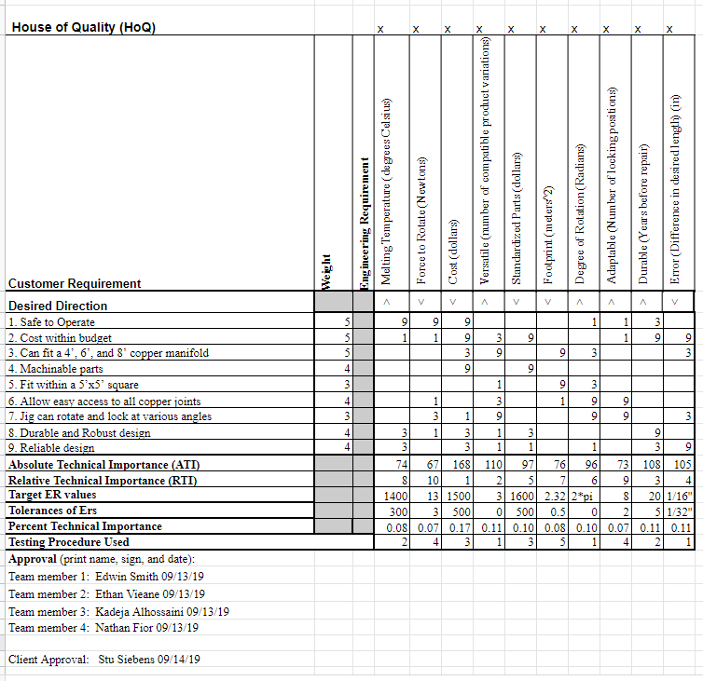

## 13.2 Appendix B: Bill of Materials

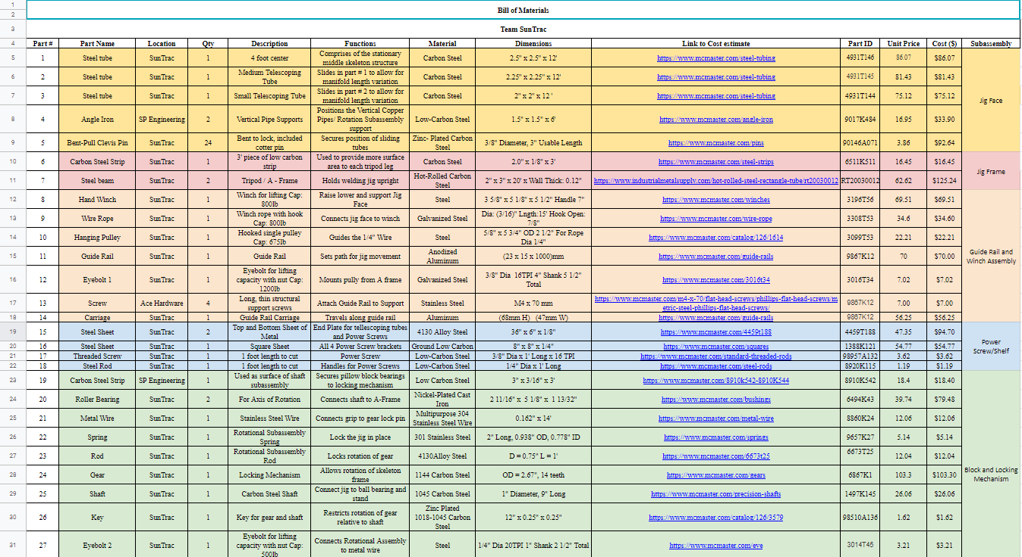



## 13.2.1 Appendix B: Bill of Materials Summary

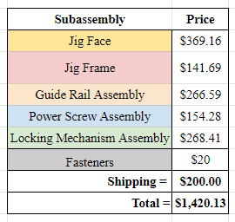

## 13.3 Appendix C: Full Risk Trade Off Analysis

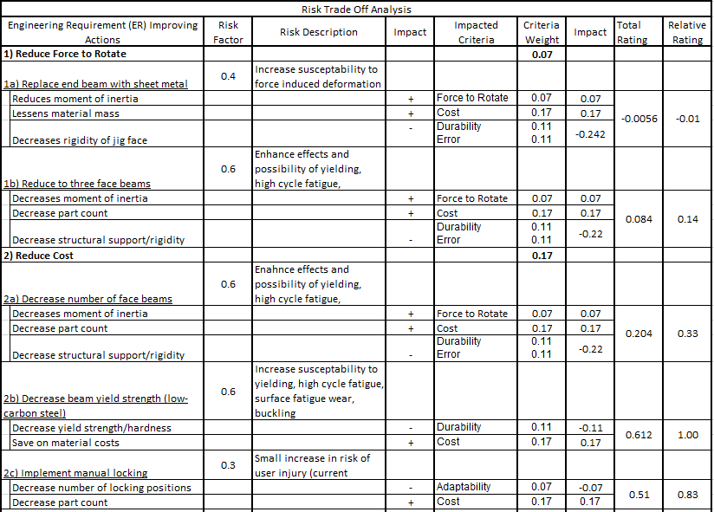

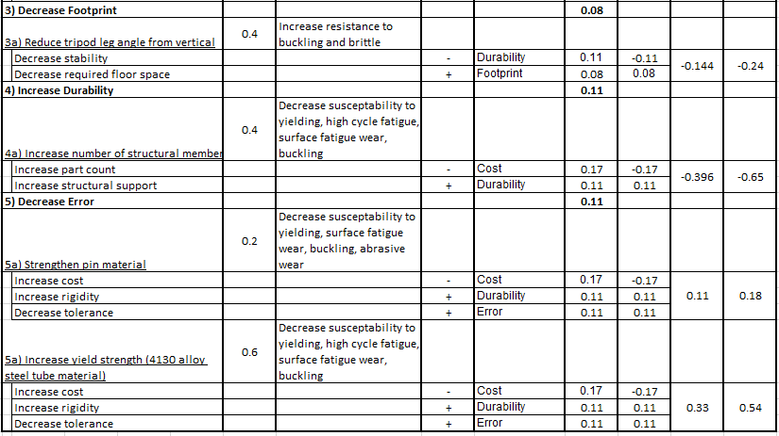

## 13.4 Appendix D: Full Components FMEA

